1/9/2025

Team 516:

NASA-JSC & Amentum Space Exploration Group

Lunar Dust Glovebox

Mina Brahmbhatt, Peter Mougey, Ryan Dreibelbis, Nia Britton, Lawrence Terrell, Kendall Kovacs​

FAMU-FSU College of Engineering 2525 Pottsdamer St. Tallahassee, FL. 32310

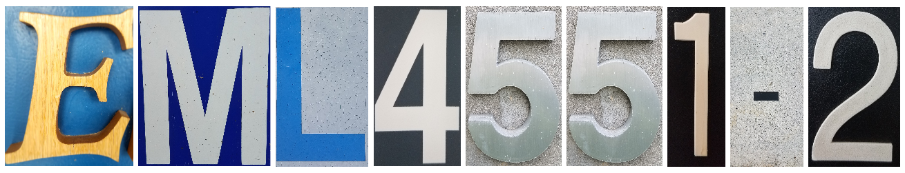

# Acknowledgement

Team 516 would like to thank our sponsors, National Aeronautics and Space Administration’s Johnson Space Center (NASA-JSC) & Amentum Space Exploration Group (ASEG) for their dedication of time and resources has benefited our understanding of engineering and teamwork. Their excitement to mentor has kept us inspired and eager to work our hardest. Thank you for this opportunity and experience to better ourselves as future engineers.

Team 516 would like to thank our past professors, especially Dr. McConomy. The hard and soft skills needed for this project would not have been possible without his help. Florida Agricultural and Mechanical University – Florida State University (FAMU-FSU) College of Engineering has provided a student-oriented platform that has exceeded all expectations. Team 516 will continue post-graduation to use and build on these skills that faculty and staff have provided.

Table of Contents

Abstract **Error! Bookmark not defined.**

Acknowledgement 2

List of Tables **Error! Bookmark not defined.**

List of Figures **Error! Bookmark not defined.**

Notation **Error! Bookmark not defined.**

Chapter One: EML 4551C 6

1.1 Project Scope 6

1.2 Customer Needs 14

1.3 Functional Decomposition 17

1.3. Functional Decomposition **Error! Bookmark not defined.**

1.3.1 Introduction 17

1.4 Target Summary 28

1.5 Concept Generation **Error! Bookmark not defined.**

Concept 1. **Error! Bookmark not defined.**

Concept 2. **Error! Bookmark not defined.**

Concept 3. **Error! Bookmark not defined.**

Concept 4. **Error! Bookmark not defined.**

Concept n+1. **Error! Bookmark not defined.**

1.6 Concept Selection **Error! Bookmark not defined.**

1.8 Spring Project Plan **Error! Bookmark not defined.**

Chapter Two: EML 4552C **Error! Bookmark not defined.**

2.1 Spring Plan **Error! Bookmark not defined.**

Project Plan. **Error! Bookmark not defined.**

Build Plan. **Error! Bookmark not defined.**

Appendices 43

Appendix A: Code of Conduct 81

Appendix B: Functional Decomposition 88

Appendix C: Target Catalog 89

Appendix A: APA Headings (delete) **Error! Bookmark not defined.**

Heading 1 is Centered, Boldface, Uppercase and Lowercase Heading **Error! Bookmark not defined.**

Heading 2 is Flush Left, Boldface, Uppercase and Lowercase Heading **Error! Bookmark not defined.**

Heading 3 is indented, boldface lowercase paragraph heading ending with a period. **Error! Bookmark not defined.**

Appendix B Figures and Tables (delete) 91

Flush Left, Boldface, Uppercase and Lowercase **Error! Bookmark not defined.**

References 96

# Chapter One: EML 4551C

## Project Scope

**1.1.1 Project Description**

The objective of this project is to optimize air flow to evenly distribute lunar dust simulant throughout a lunar dust glovebox. The glove box will make strategic use of fan placement to evenly disperse lunar dust simulant in the glove box and be spacious enough to hold the hardware and equipment necessary to observe the effects of lunar dust simulant. (McConomy, 2024).

Figure 1: Sponsor version of glovebox. This image showcases the build and components of the glovebox that Team 516’s sponsors have created and want Team 516 to recreate.

**1.1.2 Key Goals**

Key goals as described for the scope of this project detail the desired effect this product has on the user beyond the capacity of its technical functions. The key goals for Team 516 are to model lunar dust simulant and airflow characteristics using computational fluid dynamics (CFD) software, construct a glovebox prototype for testing, experiment with lunar dust simulant, compare virtual simulations with post-test results, and define and execute successful positioning of the fans.

The first key goal is to use CFD to study and understand how air will move in relation to the project. CFD software will allow the creation of computer simulations that show how air flows and mixes with lunar dust simulant. By using this software, the best places to put fans can be determined so that the lunar dust simulant spreads throughout the box and creates an even coating. The computer simulations will be compared with real-life tests to see how closely they match. The physical glovebox will validate the CFD model and serve as the “final arbiter.” Two official CFD simulations will be run to improve the model and make better predictions for future tests.

Another key goal of this project is to build an engineering glovebox prototype for testing. This glovebox will create a sealed environment where hardware and simulated lunar dust can interact during controlled experiments. To ensure it meets the project’s needs, a prototyping process will be followed that involves designing, building, and refining the glovebox until it works as desired. Using the dimensions provided by the project sponsors, a version will be created that fits measurement specifications.

An important key goal of this project is to experiment with lunar dust simulants. The team will carefully select two simulants that best match the density of real lunar dust for the tests being conducted and decide on the specifics of the entire experimental procedure. The simulant and procedure style choices will significantly impact the overall outcome of the project. Team 516's sponsors have discussed introducing the team to the head of the official Dust Mitigation project's Simulant Committee, which will help ensure that safety and health risks are properly addressed.

The visualization of the airflow using fluorescent material is an additional key goal.  To better visualize how the lunar dust simulant moves, the plan is to pair the lunar dust simulant with a fluorescent material, since the lunar dust simulant particles will be smaller than what can be seen with the naked eye. This fluorescent material will match the density of the lunar dust simulant and is essential to see how the lunar dust simulant is moving in the glovebox. Additionally, it is important that the particle size distribution of the simulant particles are like those observed in the NASA Apollo missions, but it is essential that the density of the simulant particles is as similar to those observed in the NASA Apollo missions. The matching density is what will help ensure that the particles will loft like real lunar dust would in the air and will provide the closest representation of actual celestial deposits.

An additional key goal of this project is to compare virtual simulations with post-test results. If the virtual CFD simulations match the physical tests, this will validate a way to control the behavior of the lunar dust simulant. While CFD provides valuable insights, it has its limitations. Two testing runs will be conducted and the resulted will be analyzed with respect to the CFD. Understanding the reasons behind any similarities or differences will help validate the experiments and enhance the reliability of the findings.

The last key goal is for Team 516 to control the behavior of the lunar dust simulant through finding the most successful positions for fans to evenly mix and distribute the lunar dust simulant throughout the glovebox. This is critical to ensure the simulant circulates evenly, is distributed in the air evenly, and does not settle in places that have little to no value (like the corners of the glovebox, for example). NASA & Amentum Space Exploration Group's current glove box designs have a continuous problem of lunar dust simulant building up in the corners of the glove box. Finding a way to control the simulant and positioning the fans to create a constant, evenly mixed flow of the lunar dust simulant is vital to prevent the detrimental buildup of lunar dust simulant on hardware.

**1.1.3 Market**

Lunar gloveboxes are important because they help scientists and engineers simulate the effect that lunar regolith has on objects on the lunar surface in a controlled environment. Therefore, the primary markets are space agencies such as NASA and SpaceX. This glovebox will create a controlled atmosphere allowing agencies to test the effects of lunar dust simulant on desired objects. The market for a lunar glovebox is niche as only certain companies would covet it due to their interest in science and engineering, but the market will grow as space exploration progresses. Observing the effects enables engineers to make informative decisions when it comes to material selection and design. The competitor product in the market is the glovebox NASA and Jacobs Space Exploration Group already has in use. Team 516 can compare their results to past experiments to decide if the new glovebox is successful.

The secondary markets are environmental agencies and scientists. The glove box will be designed to withstand very harsh simulant. Therefore, it can be assumed that smoother particles, like sand, can also be tested. Testing with sand inside the glovebox can simulate environments like beaches or the desert. Scientists can use this information to learn about erosion, water pollution, and sedimentation process. Other particles acting like debris simulant can also be inserted to simulate tornados, windstorms, and other natural disasters. Scientists interested in planetary science will want a lunar glovebox to research lunar regolith.

An additional market is the automotive industry. Utilizing the glovebox on a larger scale as a wind tunnel can help engineers test vehicle aerodynamics. This can be used to reduce drag, improve fuel efficiency, and optimize car performance overall. The glovebox can also be used to test the protective coating and paint of a car. By inserting rocks or smaller particles, exposure to harsh environmental elements can be simulated within the confined space. This can allow researchers to better understand and create products that can withstand the outside environment long term.

Another market is the military. Many technologies such as drones and several kinds of vehicles will be subject to extraneous conditions that can be simulated on a small scale using a glovebox like the one we are designing. It can be used for the same purposes as used by NASA and Amentum in testing hardware, but with materials commonly found on Earth instead such as sand and dirt. It can also be utilized as a small-scale wind tunnel to test fluid (muddy water, hazardous liquids, etc.) flow over various objects or hardware.

The final market would be marine companies. Shell bits, algae, dirt, and sand can all be used in the glovebox to simulate the environment relating to a body of water. Samples of sail fibers can be tested to better understand the effects of bodies of water and surrounding areas. This testing can benefit the lifespan and resistance to debris for marine sails.

**1.1.4 Assumptions**

The team will model the glovebox after a prototype already created, tested, and used by NASA, using the specifications provided. The “dust” refers to lunar dust simulant, with a particle size range between 1-4 micrometers. Lunar simulant movement will be observed using tiny, fluorescent glass spheres and chosen based on lunar dust simulant data from the team’s sponsors. It is assumed that the lunar dust simulants chosen will not have all the same properties as real lunar dust, but a simulant with similar density will be prioritized first, with a similar sizing also taken into consideration. Electrostatics, simulant erosion, and moisture effects are to be neglected, as it is assumed there is less than 0.5 weight percent water in the glovebox. The atmospheric pressure, gravity, and other properties of air within the glovebox will be the same as those on Earth. The glovebox cannot replicate lunar gravity, and so therefore replicating the lunar gravity is not a critical consideration in this case.  In this experiment in particular, the concern is not fully replicating the lunar environment, but rather controlling the behavior of the lunar dust simulant to be evenly mixed regardless of the difference between lunar and Earth gravity.  Computer fans will be utilized as the way to distribute airflow. It is assumed that Particle distribution within the glovebox will be measured from a 2D perspective using ImageJ software, which will be an accurate way to measure “even mixing” of the lunar dust simulant in the glovebox. Also, visual observations of the fluorescent material will be used to assess “even” mixing, along with images pre-, during, and post-testing. Two simulations using CFD will be completed prior to physical runs in the glovebox. Two test runs will be completed for two different lunar simulants.

**1.1.5. Stakeholders**

This project is under the jurisdiction of the FAMU-FSU College of Engineering. The internal stakeholders are Team 516 and their academic supervisors. The academic supervisors include the professor of the Senior Design course (Dr. Shayne McConomy) and the teaching assistants (Elias Haase, Tripp Lappalainen, and Jacob Schmitt). Dr. Brandon Krick is the official advisor of the project. Krick received his doctorate, master’s, and bachelor's degrees in mechanical engineering from the University of Florida. Krick investigates the origins of friction, wear, materials deformation, and adhesion on various surfaces in different environments, including nanocomposites in space. He has performed material experiments on the International Space Station. These internal stakeholders have significant influence on the project. In addition, the Environmental Health and Safety (EHS) department at FSU is an internal stakeholder as they have regulatory jurisdiction concerning the use of microparticles, and thus have influence over our project through its use of lunar dust simulant.

This project has various external stakeholders. The primary stakeholders are NASA and Amentum who will use the product and results to verify and test their own scientific research on lunar dust. NASA is a government agency with leading industry research in Earth science and space. They operate the International Space Station, a space laboratory, in hopes of advancing technology and aeronautics. Their future goals include furthering the Artemis campaign, an effort to sustain human life and exploration on the Moon (NASA, 2024). Amentum supports various engineering projects for NASA at Johnson Space Center. Amentum has also supported NASA Marshall Space Flight Center since 1989 (Belt, 2018). Under contract, they conduct research, systems engineering, testing, and analysis for NASA. The end beneficiaries of this project are the agencies’ scientists who will use the findings obtained to further their research and the astronauts whose space exploration is made safer as a result.

Dr. Rebekah Sweat Downes acts as a potential stakeholder for the lunar dust glovebox project. She has a B.S. in Mathematics with a B.A. in Economics from the University of North Florida and a Ph.D. in Industrial Engineering from Florida State University. She is an assistant professor at the FAMU-FSU College of Engineering and a principal investigator at the High-Performance Materials Institute (HPMI) within Innovation Park. This research facility contains all the equipment necessary for safe nanoparticle testing. Dr. Sweat would be a potential stakeholder due to her ability to facilitate the acquisition of experimental resources.

The final stakeholders in this project are Brian Troutman, Thomas Vassiliou, Amy Fritz, and Amy Cassady. These individuals sponsor this project and remain involved by meeting with the team weekly and communicating with Team 516 through email. Brian Troutman is a Mechanical Engineering FAMU alumnus who has worked for NASA, SPACEHAB, Lockheed Martin and, now, Jacobs Engineering and Construction. He has a master's in Nanoscale Physics and has significant experience with project management, research, development, and most importantly, lunar dust. Thomas Vassiliou has a B.S. in Mechanical Engineering from the University of Texas, and has worked in many areas, including system safety, hardware management, manufacturing, systems engineering, and human landing. Amy Fritz received her B.S. in Mechanical Engineering from Prairie View A&M University. She has been involved in lunar dust research by performing tests at Johnson Space Center and leading a team of lunar dust mitigation experts within her branch. Amy Cassady obtained her bachelor’s and master’s degrees from the University of Michigan. She has experience working for Lockheed Martin and has almost 20 years of experience with NASA, ranging from the Orion vehicle to lunar campaigns.

**1.1.6 Summary**

The sponsors emphasize the importance of Team 516 understanding the transition from an academic to a real work environment. To meet key goals, the team will collaborate with stakeholders and maintain consistent, effective communication with advisors and sponsors. Safety is a top priority, as the lunar dust simulant is hazardous due to its small microstructure. With the entire team's dedication and focus, the lunar dust glovebox will open opportunities for use and project continuity for years.

## 1.2 Customer Needs

**1.2.1. Customer Definition**

The customers for Team 516’s project are NASA and Amentum since they will use the data and results found to further their own research. The customer needs were determined through the weekly meetings with the sponsor and consulting the internal stakeholders. Further questions were sent through email to the sponsors to clarify our interpretation of their needs.

**1.2.2. Questions, Statements, and Needs**

Table 1 displays the question asked to the customer in the first column, the customer statement in the middle column, and the interpretated need in the third column. The third column is the customer needs and is crucial to the success of this project.

*Table 1: Customer Question, Statements, and Need*

|  |  |  |  |
| --- | --- | --- | --- |
|  | **Question** | **Customer Statement** | **Interpreted Need** |
| **1** | What is the intended use of the product we create? | We want you to engineer a glovebox to work for what we need; we use gloveboxes to simulate a bunch of different concepts. | The team designs a glovebox that will be useful in the expected space related testing environments, for other engineers and scientists outside of this specific lunar dust project. |
| **2** | What about lunar dust are you interested in finding out about? | Lunar dust is a significant issue in space, certain properties make it difficult to deal with. We are interested in seeing how the lunar dust can be distributed evenly. | Lunar dust simulant is evenly distributed throughout the glovebox. |
| **3** | How do we decide what lunar dust simulant to use? | You will choose the lunar dust simulant based on the particle density that is most similar to lunar dust data that is lofted. | The lunar dust simulant has a particle density within 10 microns of lofted lunar dust data. |
| **4** | How would you like to go about testing this? | I recommend you prototype in the first semester. Try to model the glovebox using CFD software at first. | The team creates a virtual simulation of the lunar dust glovebox. |
| The team builds a glovebox prototype to test upon. |
| **5** | What are the size requirements of the glovebox? | The dimensions are 3 ft x 2 ft x 2 ft and you recreate that while also considering fan placement. | The glovebox is 3 ft x 2 ft x 2 ft. |
|  | **Question** | **Customer Statement** | **Interpreted Need** |
| **6** | Could you please specify what components, or hardware will be placed inside the glovebox? | It is not necessary to have a test article inside the glovebox. As your task pertains to optimization of air circulation, your focus will be on visualizing the airflow and ensuring even mixing. | A test part is not required inside the glovebox for the experiment trials. |
| The components inside the glovebox are hardware necessary to ensure even mixing and visual lunar dust simulant distribution. |
| **7** | What type of fans are we planning to use for this project? | You will be using computer fans similar to those used in our glovebox. | Computer fans will be used by the team to circulate air inside the glovebox. |
| **8** | What materials will we need to manufacture the glovebox? | I believe that the glovebox is using polycarbonate or similar material, I will confirm this, and any other materials needed. | The glovebox is made of polycarbonate material and seals specifics are up to Team 516. |
| **9** | Are there any environmental hazards associated with the disposal of the simulant? (I know you said the simulants are toxic to wildlife, specifically aquatic wildlife. We can also talk to Ross about this.) | Yes, all simulants have some degree of crystalline silica, which is an inhalation hazard. Simulants also generally pose threats to wildlife. The degree to which a particular simulant poses a threat to wildlife depends on the simulant, but in general, you will not be disposing of simulant in wastewater, sewer systems, or other exposure methods to the natural environment. | The lunar dust simulant is disposed of in a controlled way such that there is no adverse effect on human, aquatic, or wildlife ecosystems. |
| **10** | Is there a certain velocity range the fans are expected to operate at within the glovebox? | Let me get back to you with some better data on that. You ultimately have control over this factor. | The velocity range of the fans is up to Team 516 to decide. |
|  | **Question** | **Customer Statement** | **Interpreted Need** |
| **11** | What specific environment are we aiming to simulate in the glovebox? | This glovebox would be closest to replicating a spacecraft cabin environment, i.e., standard temperature and pressure, but at Earth gravity. | The glovebox simulates an environment held at standard pressure and temperature under Earth’s gravity. |

**1.2.3 Summary**

Team 516 needs to design a glovebox to simulate the mixing of lunar dust simulant with air, using computer fans for even distribution. This will enable observation and comparison with computational fluid dynamics (CFD) simulations.

The focus will be on optimizing airflow and achieving uniform mixing without the need for a test article. Prototyping will start in the first semester with CFD modeling, replicating spacecraft cabin conditions. Team 516 will also address material and safety considerations for handling simulants.

## 1.3 Functional Decomposition

### 1.3.1 Introduction

Functional Decomposition is a visual representation of the final design and what it must accomplish. The objective is to portray functions derived from customer needs and organize them into a system and subsystem categorization. The functional decomposition is beneficial because it breaks down the system into smaller parts in order for Team 516 to gain a complete understanding of the functions of the lunar dust glovebox. Figure 1 below portrays our functional decomposition tree.

**1.3.2 Data Generation**

This information was obtained from numerous customer meetings with NASA and Amentum. There are already other lunar dust gloveboxes in use with NASA, and the customer constrained this project to follow the same specifications that the existing gloveboxes use. The customer has already specified measurements, materials, functions, and other requirements for Team 516 to follow that must be mirrored to the already existing glovebox. Therefore, most of the systems and subsystems in the functional decomposition are fixed.

**1.3.3 Hierarchy Chart and Cross-Reference Tables**

The customer needs were used to define the systems, the subsystems, and functions shown in the hierarchy chart. The hierarchy chart shows the breakdown of the systems into smaller subsystems and the functions they carry out as the chart flows from left to right in Figure 1.

The hierarchy chart shows that Team 516’s project is broken down into two systems. The first system is simulation. Using computational fluid dynamic (CFD) software, Team 516 will create virtual experiments mirroring the lunar dust glovebox. The virtual trials will create a framework for the team of how to position the fans and simulant entrance in the tangible glovebox. Using CFD will save money and time by simulating the position of the fans and air flow.

The first subsystem under simulation is “models particle distribution.” This is an action that the team plans to accomplish during CFD. The goal is to model the virtual particles to how they will act in reality. The functions of this subsystem are to calculate volumetric loading and virtualize particle position. Calculating the volumetric loading allows the team to quantify how evenly distributed the particles are inside the virtual glovebox. The function of visualizing particle position allows the team to observe the particle distribution and pinpoint the location of particles when needed.

The second subsystem under simulation is “models airflow.” It is vital that the CFD can model the airflow created by the fans. The first subsystem is to determine the fan position. The fan position is the most important factor because it impacts particle flow and distribution the most. Running numerous trials with different fan positions virtually sets the team up for success when constructing the glove box manually. These trials will give the team the best possible option for fan positioning. The second sub subsystem is “air angle.” This is the angle the air will flow due to the fan position. The air angle is important because it has a relationship to the particle distribution due to how the air flows through the glovebox. The third sub subsystem is “calculate air velocity.” The CFD needs to be able to calculate the air flow speed because it allows the team to know which speed setting to set the fan at. Depending on the results, the team will know whether to speed up or speed down the fans.

The second system of the glovebox is the physical experiment. The experiment will be the prototype of the lunar dust glovebox and will be used to verify if the CFD simulation and analysis done before prototyping is accurate. The experiment can be broken down into four smaller subsystems that define key functions of the glovebox. These four subsystems include electronics, simulant entrance, enclosure, and the simulant.

The electronics subsystem under experiment defines the key electronics involved for the glovebox to function properly, specifically with the use of computer fans, as specified by the customer. The use of computer fans is broken down further into smaller functions, such as how the fans maintain a steady airflow and be able to loft the simulant, powering the fans with the use of wires and an external power supply, and the switches that turn on and turn off the fans. The position and strength of the fans will have already been determined through the CFD analysis.

The simulant entrance subsystem defines how the simulant will be deposited into the glovebox. The way that the simulant enters the glovebox and its ability to keep the simulant inside is crucial to the project due to the damaging effects of lunar dust simulant. It can be broken down into two smaller subsystems including the funnel mechanism, and if the entrance is resealable. The customer specified that a funnel is used to deposit the simulant into the glovebox. The funnel mechanism can be broken down further into its ability to deposit the simulant and how it mounts to the glove box.

The enclosure subsystem of the glovebox defines the key functions that the glovebox itself fulfills. It can be split up into smaller subsystems that include visibility inside the glovebox, the stability of the glovebox, and its ability to seal the contents. The glovebox will remain stable by minimizing vibrations caused by external sources as well as from operation of the fans inside the glovebox. The glovebox will also seal the contents inside from leaking/escaping, as well as prevent external influences such as foreign particles or humidity from entering the glovebox. Information or recommendations about the enclosure subsystems has been or will be provided by the customer, including the dimensions of the enclosure, the material the enclosure will be made of, and potential solutions to seal the glovebox to prevent leaks from occurring or humidity build up inside.

The simulant is the fourth subsystem that comprises the experiment and it defines how the simulant can be measured such that it matches the results from the simulation. The simulant subsystem is broken down into two smaller subsystems that include visualizing the simulant particles during the test and selecting a simulant that matches the closest with the density of current, real lunar dust data. Methods for visualizing the lunar dust simulant as it is being aerosolized have been recommended by the customer, such as using glass nanospheres mixed with the lunar simulant when being tested and shining a UV light through the glovebox to illuminate the nanospheres. Various resources for lunar dust simulants have been provided by the customer to help narrow which simulant would be most suitable for the project.

Figure 2: Functional Decomposition Tree. This breakdown of the project has different levels for systems, subsystems, and functions.

*Table 2****:*** *Cross-reference table of experiment functions and systems*

|  |  |  |  |  |
| --- | --- | --- | --- | --- |
| **Functions** | **Systems** | | | |
| Electronics | Simulant Entrance | Enclosure | Simulant |
| Loft simulant. | **X** |  |  | **X** |
| Maintain steady air flow. | **X** |  |  |  |
| Turn fans on. | **X** |  |  |  |
| Turn fans off. | **X** |  |  |  |
| Provide power from outside enclosure. | **X** |  | **X** |  |
| Deposit simulant. | **X** |  | **X** |  |
| Mount to glovebox. |  | **X** | **X** |  |
| Can be resealed. |  | **X** | **X** | **X** |
| Allows visibility of particle position. |  |  | **X** | **X** |
| Minimizes excess vibrations. |  |  | **X** | **X** |
| Minimizes humidity allowances. |  |  | **X** | **X** |
| Minimizes tolerance for non-simulant particles. |  |  | **X** | **X** |
| Simulates lunar dust behavior |  |  |  | **X** |

*Table 3****:*** *Cross-reference table of simulation functions and systems*

|  |  |  |
| --- | --- | --- |
| **Functions** | **Systems** | |
| Air Flow | Particle Distribution |
| Calculates air flow velocity. | **X** | **X** |
| Calculates air flow angle. | **X** |  |
| Determines fan position. | **X** |  |
| Visualizes particle position. |  | **X** |
| Calculates Volumetric Loading. |  | **X** |

**1.3.4 Connection to Systems**

For the “Experiment” subsystem, there are more functions that relate to this subsystem than the “Simulation” subsystem because the “Experiment” subsystem requires actual hands-on construction and verification. “Loft Simulant” function will relate to this subsystem because in the physical lunar glovebox, the simulant will be propelled in order for the simulant to spread around the box. Functions such as: maintain study airflow, turning fans on and off, provide power from outside the enclosure, and deposit simulant all require electronic devices to execute their tasks in subsystem. The most important column in the functional decomposition table for the “Experiment’ subsystem is the enclosure column because it has the most functions related to it. The functions that are related to the enclosure column are: provide power from outside enclosure, deposit simulant, mount to glovebox, can be resealed, allows visibility of particle position, minimizes excess vibrations, minimizes humidity allowances, and minimizes tolerance for non-simulant particles. Each of these functions deal with the boundaries of the glovebox.

The second most important column related to the “Experiment” subsystem is the simulant column. Functions such as: can be resealed, allow visibility of particle position, minimizes excess vibrations, minimizes humidity allowances, minimizes tolerance for non-simulant particles, and simulates lunar dust behavior correlate to the simulant column because simulant is involved in order to perform the aforementioned functions.

The least important column is the simulant entrance column because it has the least number of related functions with the only two being mount to glovebox and can be resealed. These two functions relate to this column because the simulant entrance has to be connected to the glovebox and the entrance needs to be able to be resealed for continued use.

**1.3.5 Smart Integration**

The success of this project is directly related to the integration of its various systems. Each system has an independent function that contributes to the overall functionality of the project. This allows the “bigger picture” of the project to be organized and presented in a table format. Below are the tables that illustrate this method.

*Table 4: Experiment Smart Integration Potential*

|  |  |
| --- | --- |
| **Function** | **Ranking (out of 10; 1 4 7 10)** |
| Loft simulant. | 4 |
| Maintain steady air flow. | 1 |
| Turn fans on. | 1 |
| Turn fans off. | 1 |
| Provide power from outside enclosure. | 4 |
| Deposit simulant. | 4 |
| Mount to glovebox. | 4 |
| Can be resealed. | 7 |
| Allows visibility of particle position. | 1 |
| Minimizes excess vibrations. | 4 |
| Minimizes humidity allowances. | 4 |
| Minimizes non-simulant particle allowances. | 4 |
| Visualizes particle position. | 4 |
| Simulates lunar dust behavior | 1 |

Table 5: *Simulation Smart Integration Potential*

|  |  |
| --- | --- |
| **Function** | **Ranking (out of 10; 5 or 10)** |
| Calculates air flow velocity. | 10 |
| Calculates air flow angle. | 5 |
| Determines fan position. | 5 |
| Visualizes particle position. | 5 |
| Calculates Volumetric Loading. | 5 |

Electronic systems influence lofting through the operation of fans or airflow controls, which can either enhance or reduce particle movement. Maintaining steady airflow is essential for preventing unfavorable results and ensuring optimal dust performance, while electronic systems regulate this airflow via fans. Fan operation relies on electronic controls to manage airflow effectively, ensuring system stability. External power supplies also play a key role in keeping both the electronics and the enclosure functional, with their efficiency influenced by how Team 516 handles and adjusts all power-related sources.

Simulant deposition is affected by the electronics and enclosure systems of the glovebox, particularly in how quickly the fans act on the dust after insertion and how the simulant behaves based on the enclosure’s shape and setup. A properly sealed enclosure is critical to maintaining the integrity of the glovebox, ensuring the strength of the simulant entrance, and keeping the amount of testing simulant consistent. The mounting of a simulant-depositing area must be compatible with the enclosure’s functionality, maintaining a secure, sealed environment. Once the simulant is inside, the ability to reseal the glovebox ensures that both the enclosure and simulant systems remain contained and controlled. Particle visibility is a crucial, non-negotiable aspect of the project, and clear visibility inside the glovebox, determined by the materials used, allows Team 516 to monitor particle behavior and ensure the effectiveness of the simulant flow system.

Minimizing excess vibrations is essential for maintaining the stability of simulant particles, as disturbances can disrupt airflow and alter particle behavior outside of the parameters being tested. Enclosures and electronic systems must work together to reduce vibrations, which can impact both system performance and experimental accuracy. Humidity control is another critical factor, as excess moisture can affect simulant usability and alter its behavior; thus, the enclosure must remain dry. Additionally, keeping unwanted particles out of the system is vital for maintaining simulant purity. Finally, simulating lunar dust behavior requires accurate use of CFD and fan placement, which affects the design of the enclosure and simulant systems.

Air flow velocity plays a key role in particle distribution, with higher velocities transporting particles more quickly and spreading them further. The angle of airflow directly influences this distribution, with steeper angles having more specific, aggressive effects on dust movement. The interaction between airflow and surfaces during CFD testing will help Team 516 adjust these angles, altering the overall flow pattern. In the “Simulation” subsystem, air flow of the simulation is an important component of the simulation. By discerning characteristics of the air flow inside the glovebox, it will help Team 516 determine where the fans will be positioned to ensure optimal lunar simulant lofting. The fans inside the glovebox will be simulated using CFD software which will detail vital characteristics of air flow such as velocity, Reynold's number, and the angle at which the air is flowing. By knowing the velocity of which the simulant is flowing, the fans can be tweaked until the particle distribution is conducive to the uniform simulant settling in the lunar glovebox.

The position of a fan in a glovebox also shapes airflow patterns, affecting how particles are distributed by creating areas of uniform flow or unfavorable dead zones. Particle distribution and airflow patterns will coincide with adjustments in fan positions during trials. Visualizing particle positions can reveal concentration gradients and those unfavorable dead zones, highlighting the behavior of the enclosure and simulant systems. Similarly, calculating volumetric loading influences particle distribution results in CFD testing and physical trials, with uneven distribution indicating the need for adjustments in loading.

**1.3.6 Action and Outcome**

The team will build a glovebox using the established dimensions and ensure that it is sealed properly to maintain its integrity. Fans will be positioned within the glovebox, and Computational Fluid Dynamics (CFD) simulations will be conducted before physical testing. Additionally, a visual method will be developed to capture post-experiment results. The team will analyze the visual data to produce quantified scientific results, such as particle distribution. It is crucial to ensure that the lunar dust simulant is maintained at the correct humidity levels and to prevent particle contamination during experiments. After the first round of testing, adjustments will be made to improve results for subsequent tests.

The expected outcomes include achieving even and optimized particle flow while maintaining steady and favorable airflow. The team aims to successfully control simulant insertion without any issues and ensure clear visibility into the glovebox for effective monitoring. Additionally, the optimization of fan placement and airflow angles is essential to avoid dust buildup.

**1.3.7 Function Resolution**

The function resolution of the project includes developing a virtual lunar dust glovebox simulation, constructing a physical glovebox based on the virtual simulation, and validating that the tangible glovebox aligns with the virtual results. The project is complete when Team 516 and the sponsors and stakeholders are satisfied with the results and work done.

## 1.4 Target Summary

Establishing targets and metrics is a vital part of the design process because it will allow Team 516 to compare their actual results with what was expected. Metrics are the measurements taken to evaluate the design. Targets are numerical quantities assigned to a metric that Team 516 hopes to obtain. This system designs certain standards Team 516 hopes to reach and plans how each standard will be met. Table 6 shows the most prominent functions, drawn from Team 516’s function decomposition.

*Table 6: Most Prominent Functions*

|  |  |  |  |  |
| --- | --- | --- | --- | --- |
|  | **Function** | **Metric** | **Target** | **Description** |
| 1 | Circulates Air | Measure fan velocity | Velocity = 2.0 ± 1 m/s | Velocity will be calculated based on each fan and averaged |
| 2 | Lofts Simulant | Measure particle distribution | 50% of particles between 0-0.305 m; 50% particle between 0.305-0.61 m | Measurement will be taken in intervals based on testing recording |
| 3 | Allows Visibility Inside Enclosure | Binary: The optical transmissivity of the material | 1 | Measurement based on whether the elements in the glovebox can be seen |
| 4 | Seals Enclosure | Binary: Non-porous material used | 1 | The material will keep all elements within the enclosure contained. |
| 5 | Simulates Lunar Dust Behavior | Measure the density of selected lunar dust simulant | Density is within 15% of 1.5 g/cm3 | Measurement will be based on the lunar dust data sheet |
| 6 | Models Air Flow | The density of air for CFD | 1.225 kg/m3 | Measurement based on standard density of air under normal earth conditions. |
| 7 | Calculates Air Velocity | Binary: Velocity calculated in m/s in CFD | 1 | Measurement based on pass or fail outcome from CFD run |
| 8 | Calculates Air Angle | Binary: Optimized angle of air calculated in degrees in CFD | 1 | Measurement based on pass or fail outcome from CFD run |
|  | **Function** | **Metric** | **Target** | **Description** |
| 9 | Models Particle Distribution | Binary: A model of the particles flow in the glovebox in CFD | 1 | Measurement based on pass or fail outcome from CFD run |
| 10 | Calculates Volumetric Loading | Binary: Particles per unit area is calculated in CFD | 1 | Measurement based on pass or fail outcome from CFD run |
| 11 | Simulant Fluoresces | Binary: material emits light when exposed to a UV light | 1 | Measurement based on pass or fail outcome from testing run |
| 12 | Full Test Occurs  *primary function | Amount of simulant in the glovebox during experiment | Amount of simulant > 60g | Measurement based quantity of simulant contained within glovebox based on weight |
| 13 | Earth Like Conditions | Measure standard pressure, temperature, and Earth’s gravity within the glovebox | 14.7 psi, 293.15 K, and 9.8 m/s2 | Measurement based on standard pressure, temperature, and gravity of testing room. |

**1.4.1 Critical Targets/Metrics**

The critical targets and metrics are those most directly related to the project objective, to design and build a lunar glovebox that uniformly distributes lunar dust simulant. The functions highlighted in green represent the functions from the tangible glovebox, the functions labeled in grey represent the functions from the CFD part of the project, and the orange highlighted section stems from customer needs. The rest of the targets and metrics can be found in Appendix C.

The target for metric 1 (Measure fan velocity) is that the velocity of the fan is 2.0 ± 1 m/s because that is the average computer fan velocity. During the CFD process, Team 516 will manipulate different fan velocities to locate the most optimal speed. Since the desired speed is an independent variable, Team 516 has allocated this range to their computer fan speed inputs.

The target for metric 2 (Measure particle distribution) is 50% of particles between 0-0.305 m; 50% particle between 0.305-0.61 m. Part of the project objective is that the lunar dust simulant needs to be distributed uniformly. The height of the glovebox is 0.6096 m (2ft), marking 0.305m as half the height. Team 516 chose this target because it states that 50% of the particles will be above the halfway point and half will be below at any given time. This target emphasizes the desire of the particles being evenly distributed throughout the glovebox.

The target for metric 3 (The optical transmissivity percentage of the material) was chosen to be greater than 75%. The chosen material for the glovebox is polycarbonate. During the experiment, it is vital Team 516 can see inside the enclosure to make qualitative observations. During the experiment, the simulant will be blowing, decreasing the visibility from 100%. However, the simulant will be dehydrated, decreasing the chances of the simulant sticking to the sides of the enclosure and blocking the team’s view. An optical transmissivity percentage of greater than 75% creates a realistic target, knowing that the fine simulant in motion will create some visual impairment.

The target for metric 4 (Binary: Non-porous material used) relates to how well sealed the enclosure is. The binary metric was allocated a target as 1. This means that the chosen material for the glovebox, polycarbonate, must be manufactured in a way to be non-porous. This material allows Team 516 to be able to see through the enclosure, while being confident the air and simulant inside cannot escape. In addition, this material will keep any outside air, condensation, or other particles from entering the glovebox. However, the most important factor for a non-porous material is safety. No escaping air or simulant particles will keep Team 516 and the environment safe.

The target for metric 5 (Simulates lunar dust behavior) is that the simulant will have a density within 15% of 1.5 g/cm3. The density of 1.5 g/cm 3 is the density of actual lunar dust we are trying to mirror. Lunar dust simulant vendors sell simulant that simulate real lunar dust but in different design applications. Allocating a 15% range of the desired density sets an allowable tolerance while also maintaining optimal results.

The target for metric 6 (The density of air for CFD) is 1.225 kg/m3. To ensure realistic results, the density for air used in the CFD has to mirror the density of air that will be used for the tangible glovebox. Therefore, this metric was assigned the density of air.

For functions 7 through 10, their metrics are categorized as binary where the targets are set to one as this signifies a successful calculation by the CFD.

**1.4.2 Method of Validation**

Most of the testing will occur through the CFD simulation as the basis for the prototype. This simulation will determine what fan positions will theoretically produce an even mixing of the lunar dust simulant and glass nanospheres within the air. This will be further verified with testing of the physical glove box.

Using the CFD simulation will allow the team to vary certain parameters of the glove box for theoretical testing. These parameters include the position of the fans, the fans velocities and angles which will subsequently alter the air velocity and angles, and the density of the air and lunar dust simulant. The CFD will also allow for a theoretical visualization and provide measurements to be taken inside the glove box, such as the volumetric loading of the lunar simulant inside, as we the air velocity and angle. The work done with the CFD will be the basis for the physical prototype.

Regarding the physical prototype, even mixing of the circulated air with the lunar dust simulant and the glass nanospheres will be tested using UV light. The enclosure of the glove box will be transparent, and the glass nanospheres (as well as some of the lunar simulant) will be fluorescent when exposed to UV light, providing a visual indication the lunar simulant is being lofted. This will verify that the lunar simulant is being aerosolized by the fans. The speed of the fans will be measured using an anemometer and the fans will be powered by an electrical outlet. Baking the simulant at a high temperature for twelve hours will ensure dehydration. This will prevent any clumping or simulant sticking to the walls. Lastly, the strength of the sealing for the enclosure must be tested to know the sealing will not fail. This can be validated by using the sealant to lift a weight of at least 2.28 kg.

**1.4.3 Derivation of Targets/Metrics**

The following targets and metrics are those not considered critical and can be found in Appendix C. The target for metric 3 (The flow of the air at different time intervals) is that the air contains a Reynolds number > 4000 at every 30 second interval. Reynold’s number will detail the characteristics of air flow inside the glovebox. An Airflow meter will be used to determine the flow of the air inside the box, from there Reynold’s number will be calculated. This metric was derived from the idea of multiple small fans inside a small box should induce a turbulent flow. The time interval (30 seconds) seems to be a great interval as the fans will only run for about 5 minutes.

The target for metric 4 (Measure fan velocity, time fan deactivates after switch has been turned off) is that the fan velocity > 1 m/s in < 10 seconds after the switch is turned on and the fan velocity = 0m/s in < 10 seconds after the switch is off. During the experiment, it is vital a steady airflow is reached quickly. This will save time and power during the experiment. Therefore, Team 516 hopes to integrate the fans in a way they will simultaneously at the same speed.

The target for metric 5 (Measure entrance diameters) and metric 6 (Measures the holding strength of adhesive connecting funnel to glovebox) are Top diameter = 0.61 ± 0.305 m; Bottom diameter = 7.62 ± 25.4 mm and Adhesive Strength = up to 2.28 kg. The targets and metrics describe the funnel used to deposit the simulant. The targets for metric 5 were found by Team 516 researching different funnels and averaging the products they thought would work for the glovebox. The targets were given ranges because the exact size of the funnel used it not yet known. The target for metric 6 was chosen because the given adhesive strength is the average holding strength of the chosen adhesive material to connect the funnel and glovebox. In finding this metric, the absolute strongest type of adhesive was considered in order to make sure the funnel and glovebox are adjoined securely such that the vibrations from the case fans do not cause the funnel to slip on the glovebox.

**1.4.4 Beyond the Functions**

Beyond creating targets and metrics for each function, Team 516 addressed three additional needs that targets and metrics were created for. The first additional need is that the simulant fluoresces. The metric is a binary metric: that the material emits light when exposed to UV light. The target is 1, which means we are targeting for the metric to occur. For a material to visibly fluoresce, the material will emit light once exposed to electromagnetic radiation (UV light). The method of validation will be that the material on the simulant emits lights once exposed to a UV light. If it does, the material is fluorescent, and the target is met.

An additional need is that full tests are run. For a full test to occur, the proper amount of simulant must be used. Hence, the metric is the amount of simulant in the glovebox. The target is at least 60 grams. This amount came from a meeting with a simulant specialist, Dr. Ross Kovtun, from NASA. The verification method will be to weigh the simulant.

Another additional need is that the glovebox simulates earth-like conditions. This is because the research benefits lunar dust mitigation within space stations, like the International Space Station. The metric would be the standard pressure, temperature, and Earth’s gravity within the glovebox. This target would be 14.7 psi, 293.15 K, and 9.8 m/s2.

**1.5 Concept Generation**

**1.5.1 Introduction**

Concept generation involves activities and tools that facilitate brainstorming project ideas. Combined with an understanding of the project objective, group brainstorm sessions took place where 100 potential concepts were generated for the lunar dust glovebox. All 100 project ideas can be found in APPENDIX. Listed below are the tools used to generate these 100 potential concepts as well as five medium fidelity concepts and three high fidelity concepts.

**1.5.2** **High Fidelity Concepts**

Improving the working Lunar Glovebox model that NASA currently is in possession of, this innovation will include optimal fan positioning, an adjoined funnel, and curved surfaces covering the edge of each corner of the glovebox. For the Curved Corner Concept (concept #103), one of the main concerns of the sponsor is solved, which is the lunar simulant accumulating in the corners of the glovebox. By utilizing curved edges with ceramic coating, the curved edges can repel lunar simulant when it is lofted towards the corners. Geometrically, curved edges would reduce the amount of simulant buildup compared to a corner edge which has a pocket for the simulant to accumulate in. The fans would be positioned in the middle on each face of the box.

Figure 3: High Fidelity Concept 1: This design features curved inner corners and four case fans placed on the glovebox floor, with one funnel at the glovebox ceiling.

The Starfish Limb Arrangement Biomimicry Concept (concept #56) features an airflow system inspired by the starfish limb arrangement. The design uses five fans arranged symmetrically in a star pattern, each angled towards the middle of the glovebox to ensure a balanced and even distribution of air throughout the enclosure. The glovebox includes a single funnel positioned at the top, fabricated from 3D-printed material. The enclosure would be sealed with O-ring seals made of rubber, ensuring a tight barrier to prevent leakage. The choice of polycarbonate for the glovebox material offers high visibility and strength.

Figure 4: High Fidelity Concept 2: This design features fix fans placed in the glovebox as symmetrically as possible, with one funnel at the glovebox ceiling.

The 1st Morphological Chart Concept (concept #1) is derived from a morphological chart by selecting options from each design category. In this concept, there are four case fans that will be placed on the top and bottom of the glovebox. Two fans on the top and two on the bottom will be placed at a 45-degree angle from horizontal by use of a stand to achieve the desired air angle in order to ideally loft the lunar simulant. This design will include two standard funnels to deposit the simulant from the previous ideas.

Figure 5: High Fidelity Concept 3: This design features four fans, with two on the ceiling, and two on the floor, with two funnels.

**1.5.2** **Medium Fidelity Concepts**

The Extreme Fan Velocity Concept (concept #80) will utilize a single computer fan that can run at the fastest velocity possible. This fan will be placed on the top of the glovebox facing downward. By utilizing one fan at the fastest velocity, the airflow will be consistent and not interfere with other fan’s velocities profiles. Setting it at the fastest velocity possible will help ensure all simulant particles remain lofted.

In the Oscillating Fans Concept (concept #79), the case fans inside the lunar glovebox will be able to move horizontally by using a pin in slot mechanism that automatically moves the fans back and forth. Each fan would be placed on the faces of the box and adjusted accordingly to properly loft the simulant and achieve a uniform distribution. However, using the pin in slot mechanism restricts the angle at which the case fans can blow air (air angle) so there are some limitations.

The Detachable Funnel Piece Concept (concept #73) includes a polycarbonate glovebox with a detachable funnel/puzzle piece cap design for material insertion. The entrance for the simulant is a hole at the top of the glovebox, where a funnel made from the hole diameter dimensions (using 3D printed material) can be temporarily placed to facilitate the insertion of the simulant. Once the simulant is deposited, the funnel is removed, and the hole is sealed using a puzzle piece cap cut from the glovebox itself, secured with a reusable rubber O-ring seal to ensure an airtight closure. Two compressors run for the duration of the experiment to push out dust and humidity, creating a dry environment inside the glovebox. The process requires quick simulant deposition to maintain the dry conditions.

The 23rd Morphological Chart Concept (concept #23) is another design derived from a morphological chart by selecting options from each design category. The glovebox is made of plexiglass for optimal visibility and features four fans positioned on the bottom, all facing upward to ensure effective air circulation. Two funnels made of cardstock are placed on the top side of the glovebox for material entry. To seal the environment, a compression seal made of silicone is used. This design balances functionality and transparency.

The Tree Biomimicry Concept (concept #51) is a polycarbonate glovebox idea with tree canopy dynamics in mind. The idea includes the use of six fans, with the outer half angled towards the center and the inner half facing straight down. This arrangement mimics the way trees in a forest orient their branches and leaves to ensure uniform shade distribution beneath the canopy. A single 3D printed funnel is placed at the top of the glovebox. The enclosure is sealed using a rubber O-ring seal for an airtight barrier. This design aims to replicate natural air and moisture management in the wild and promote even airflow and distribution.

**1.5.3** **Tools**

Various tools were used to generate 100 potential concepts for the lunar dust glovebox. These tools include biomimicry, crap shoot, forced analogy, anti-problem, battle of perspectives, and morphological charts.

Here’s a description of each method for generating engineering concepts:

**Morphological Chart**

This method involves breaking down a system or problem into its key functions or components and generating alternative solutions for each. A matrix is created where each row corresponds to a function and each column lists possible solutions. For each of the categories in the first column of Table BLANK below: Glovebox Material, Shape, Fan Placement, Fan Angles, Number of Fans, Funnel Placement, Number of Funnel Placements, Funnel Material, Seal Types, and Seal Materials, different possible solutions were listed. By combining different options from each row, numerous concept variations can be generated, fostering creativity and innovation. The first 50 concepts generated are from the Morphological Chart.

*Table 7: Morphological Matrix*

|  |  |  |  |  |  |  |  |  |  |
| --- | --- | --- | --- | --- | --- | --- | --- | --- | --- |
| **Glovebox Material:** | Polycarbonate | Glass | Wood | Cardboard | Teflon | Stainless Seals (Grade 304 and 316L) | Aluminum (Grade 5052 or 6061) | Plexiglass |  |
| **Glovebox Shape:** | Circular | Oval | Fishbowl | Triangular | Hexagonal | Rectangular | Square |  |  |
| **Fan Placement:** | All On Ceiling | All On Glovebox Floor | All On Left Side of Glovebox | All On Right Side of Glovebox | All In Top Left Corner | All In Top Right Corner | All In Bottom Left Corner | All In Bottom Right Corner | All In Middle of Glovebox |
| **Fan Angles:** | Each facing up | Each facing down | Each facing towards the center of glovebox | Half at 45˚ angle from top surface, half at 45˚ angle from bottom surface | Half at 60˚ angle from top surface, half at 60˚ angle from bottom surface | Half at 60˚ angle from top surface, half at 45˚ angle from bottom surface | Half at 45˚ angle from top surface, half at 60˚ angle from bottom surface | Half at 45˚ angle from left surface, half at 45˚ angle from right surface | Half at 45˚ angle from front surface, half at 45˚ angle from back surface |
| **Number Of Fans:** | 1 | 2 | 3 | 4 | 5 | 6 | 7 |  |  |
| **Funnel Placements:** | Top Of Glovebox | Bottom Of Glovebox | Left Side of Glovebox | Right Side of Glovebox | Front Of Glovebox | Backside Of Glovebox |  |  |  |
| **Number Of Funnel Placements:** | 1 | 2 | 3 |  |  |  |  |  |  |
| **Funnel Material:** | 3d Printed (PLA) | Aluminum Foil | Plastic Grocery Bag Type of Material | Ziploc Bag Material | Cardboard | Cardstock | Parchment Paper |  |  |
| **Seal Types:** | Oring | Flat Gasket | Compression Seal | Magnetic Seal | Inflatable |  |  |  |  |
| **Seal Materials:** | Rubber | Silicone | Resin | Metal |  |  |  |  |  |

**Biomimicry**

Biomimicry is an approach to innovation that draws inspiration from the natural world, which has thrived and adapted over millions of years. By researching the specific characteristics of living organisms that have enabled them to survive, engineers can identify parallels between natural adaptations and design challenges. For example, engineers in Japan used the shape of a hummingbird’s beak as inspiration for the design of a bullet train, improving its speed and efficiency. Similarly, Team 516 has utilized biomimicry to enhance their concept generation process. By emulating biological systems, processes, or structures, engineers can develop more efficient, sustainable, and innovative designs, leveraging nature's long history of problem-solving.

**Crap Shoot**

The Crap Shoot method encourages the generation of random or spontaneous ideas, often without restrictions. Engineers or designers throw out numerous, often unconventional, ideas in rapid succession, aiming for a broad exploration of possibilities. Although many ideas might seem impractical, the goal is to uncover unexpected solutions through sheer volume and randomness. Team 516 found ideas becoming more and more creative.

**Forced Analogy**

This method involves deliberately comparing the design problem with an unrelated object or system to identify new insights. By forcing a comparison between seemingly unrelated domains, engineers can stimulate creative thinking and explore alternative perspectives that might not have been considered otherwise.

**Anti-Problem**

The Anti-Problem method involves solving the opposite of the problem at hand. By thinking about how to worsen the situation or create the worst possible solution, engineers can often gain new insights into the actual problem. This approach encourages the team to identify the causal factors that would lead to failure, which in turn helps pinpoint critical elements that influence the project's success. By analyzing concepts developed to solve the opposite problem, engineers can uncover innovative solutions when switching back to the original challenge, allowing for more creative and effective design strategies.

**Battle of Perspectives**

In this method, team members with different viewpoints or disciplines are encouraged to argue for their perspective on the problem. The clash of these varied perspectives often leads to a deeper understanding of the design challenge and can foster the development of more well-rounded and innovative solutions.

These methods all offer diverse approaches to stimulate creativity and generate a wide range of engineering concepts during the design process.

**1.5.5 Refining Ideas**

Utilizing different concept generation methods enabled Team 516 to form initial concepts. Each unique tactic sparked new ideas of how to meet the project objective. The 100 initial concepts listed below were drawn a morphological chart, biomimicry, crapshoot, forced analogy and anti-problem. Please see Appendix A for a full list of concepts.

**1.6 Concept Selection**

**1.6.1 Binary Pairwise Comparison Chart**

The first step in selecting our final concept was to assign an Importance Weight Factor (IWF) to each of our customer needs. This was done by using a Binary Pairwise Comparison chart that would compare the customer needs against each other, assigning a value of 1 if a customer need if it is more important compared to another customer need. Summing the rows of the chart gives the IWF for that customer need, which will be used in our House of Quality. Table 8 is the Binary Pairwise Comparison chart for our customer needs.

The comparison begins with ensuring even distribution of lunar dust simulant in the glovebox, scoring a 7. This need ranks 3rd, and is important for achieving realistic simulations, as uneven dust distribution is what we are working against in our experiment. Similarly, the accuracy of the lunar dust simulant’s particle density, which has a score of 5, is crucial for mimicking real lunar conditions but less critical than other factors affecting safety and environmental impact. It ranked 7th.

The comparability of virtual and experimental results scored an 8 and ranked 2nd. The alignment between these results represents model validation and research reliability, ensuring that theoretical predictions hold true during physical testing. The need to build a prototype is closely tied, also scoring 8 and sharing the 2nd rank. Prototyping is essential for testing and refining design concepts. The glovebox’s dimensions, however, are ranked as less critical. With a score of 3, this need ranks 10th, as physical size constraints are necessary but do not directly influence performance or safety.

Ensuring proper mixing scores 5, sharing the 7th rank. This need impacts the functionality but does not directly pose a safety risk. Similarly, the use of computer fans for air flow also scores 5 and ties for the 7th rank. Compared to other needs, it's moderately important for maintaining the dust distribution. The use of polycarbonate as glovebox material has a score of 7 and a ranking of 3. This need is highly important for ensuring operational safety, visibility, and durability.

The highest-ranked need, with a score of 10, is the controlled disposal of lunar dust simulant. This emphasizes environmental safety, and the necessary steps Team 516 need to take to be compliant with standards NASA has for disposal. The velocity range of the fans being enough has a score 5 and ranks 7th. It’s crucial for simulation accuracy but less impactful than safety concerns. Lastly, simulating standard pressure and temperature conditions in the glovebox also scores 5 and ranks 7th, important for experimental validity but not as critical as safety or environmental impact.

*Table 8: Binary Pairwise Comparison Chart*

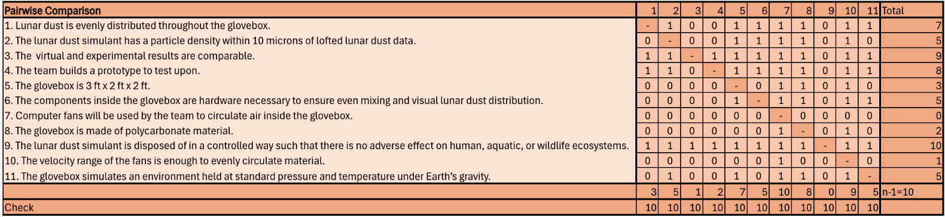

**1.6.2 House of Quality Chart**

Table 9 shows the House of Quality (HOQ) chart. The HOQ translates customer needs into engineering characteristics. These characteristics are given a numerical ranking on the scale 1-3-5-7-9 based on how well the characteristic contributes to the customer's need. The rank 1, is the lowest quantity while 9 is the highest. These quantities were derived from Team 516’s engineering intuition. From the HOQ, the median relative weight value was 12.12%. The relative weight value represents the relationship between the importance of a customer requirement and the product specifications.

*Table 9: House of Quality Chart*

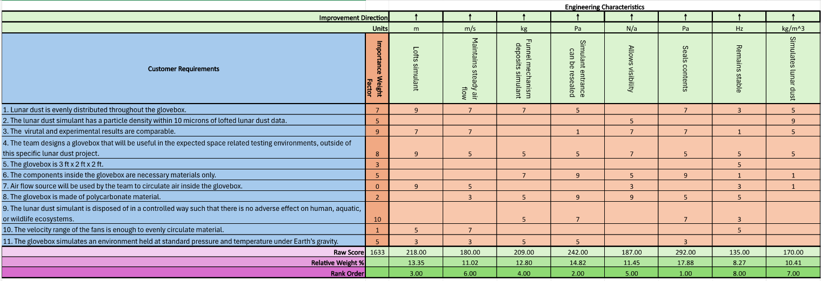

After calculating the median relative weight value, the top five engineering characteristics can then be determined and analyzed in Pugh Charts. From the HOQ, the top 5 engineering characteristics are (from most important to least important) seals components, simulant entrance be resealed, lofts simulant, funnel mechanism deposits simulant, and allows visibility.

Team 516 was satisfied with the resulting ranks due to safety. The first and second ranked engineering characteristic related to how well sealed the glovebox will be. Lunar dust simulant is miniscule and sharp. Therefore, it is toxic to touch and inhale. Team 516's first priority is safety. Sealing the glovebox ensures no lunar dust simulant will escape and harm anyone in close proximity.

The engineering characteristics that are discarded in the Pugh charts are the glovebox’s ability to maintain steady airflow, simulate lunar dust, and remain stable. Although disregarded, this does not mean these characteristics are no longer important. They were simply not as vital with regard to fulfilling the customer's needs.

**1.6.3 Pugh Charts**

The Pugh chart was utilized to evaluate various design options against specific criteria essential to the project’s success. Key engineering characteristics were weighed to reflect its importance to project goals via the House of Quality as discussed before. The top five engineering characteristics used were the project's ability to seal contents, resealing of entrances, its ability to loft the simulant, the funnel mechanism, and visibility.

Using Pugh Charts allows for a structured method of comparing concepts generated against a datum that represents the current market. For this project, the current market datum is NASA and Amentum’s current glove box. The Pugh chart compares our concepts generated to the market datum on each engineering characteristic based on a “+”, “S”, and “-” evaluation, where a “+” indicates the concept is stronger compared to the datum based on the engineering characteristic, “S” means its satisfactory or similar to the datum, and “-” indicates the concept is weaker. After evaluating all the concepts compared to the datum, the “+” and “-” were summed together and the number of “S” was subtracted to determine a ranking of the concepts, through which the two lowest ranking concepts are eliminated. Team 516 utilized two Pugh Charts for concept selection, the first chart using NASA and Amentum’s current glove box as the datum for comparison, and the second chart using a medium ranked concept determined from the first Pugh Chart, allowing for comparisons from various perspectives.

The two Pugh charts presented offer a comprehensive analysis for selecting the most suitable glovebox concept for a project, with each chart using a different datum, or baseline, for comparison. The first chart uses NASA’s glovebox design as the datum, while the second chart employs Morphological Chart Concept 1. Each chart evaluates various design concepts against critical engineering characteristics, such as sealing contents, resealing the simulant entrance, lofting simulant, depositing simulant using a funnel mechanism, and ensuring adequate visibility.

In the first Pugh chart, which compares the concepts to NASA’s glovebox, the Curved Corner design scores neutrally, with positives in sealing and lofting simulant but drawbacks in resealing and simulant deposition. The Starfish concept stands out with a high score of 7, excelling in resealing and simulant control without any negatives, making it a well-rounded and efficient option. Morphological Chart 1 receives a moderate score of 3, offering improved visibility but facing challenges with resealing. The Extreme Fan Velocity concept ranks poorly at -4, as the high fan velocity introduces significant issues with containment. Oscillating Fans yield a neutral score, performing satisfactorily across the board but lacking notable innovations. The Detachable Funnel concept scores 4, showing promise in containment and simulant deposition but requiring improvements in resealing. Morphological Chart 23 underperforms with a score of -3, highlighting difficulties in environmental control, while Tree Biomimicry ranks highly at 7, matching Starfish in effectiveness, thanks to its strong sealing and resealing capabilities.

The second Pugh chart, which uses Morphological Chart Concept 1 as the baseline, reveals a different set of outcomes. Curved Corner scores -4, indicating more issues than advantages compared to this datum, while Starfish, which performed well in the first chart, surprisingly receives a -4, emphasizing the variability of performance based on the baseline choice. Oscillating Fans perform better here, achieving a score of 3 due to their enhanced visibility. Detachable Funnel remains neutral with a score of 0, offering a stable but unremarkable performance. The Tree Biomimicry concept emerges as the top performer in this comparison, scoring 4, thanks to consistent improvements in sealing and resealing, solidifying its status as a strong contender.

Overall, the first Pugh chart highlights Starfish and Tree Biomimicry as the most promising designs when compared to NASA’s glovebox, both excelling in environmental control. The Detachable Funnel shows moderate potential, while Extreme Fan Velocity and Morphological Chart 23 are flagged as problematic. In the second chart, Tree Biomimicry maintains its effectiveness, and Oscillating Fans demonstrates some advantages, but the Starfish concept's drop in performance illustrates how critical the baseline choice is in evaluating design concepts. These results underscore the necessity of evaluating designs from multiple perspectives to ensure a comprehensive understanding of their strengths and weaknesses.

*Table 10: First Pugh Chart (Sponsor-made glovebox as datum)*

*Table 11: Second Pugh Chart (Morphological Chart Concept 1 as datum)*

**1.6.4 Analytical Hierarchy Process**

The Analytical Hierarchy Process (AHP) analysis provided insightful clarity into the strengths and weaknesses of each option considered for the project by evaluating each concept across key engineering characteristics in Criteria Comparison Matrix, Figure 10. Then the values were normalized, as shown in Figure 11. A specific weight was determined for each characteristic, with “lofts simulant” prioritized due to its importance for evenly distributing the lunar dust simulant throughout the glovebox. The consistency was checked by calculating the consistency vector, in Figure 14, and the consistency index, in Figure 14. If the consistency ratio was less than 0.1, then the matrices were consistent. This is checked to ensure characteristics are scored properly in relation to each other and minimize errors. This process was repeated, comparing the top three concepts based on their performance in each of the five most important engineering characteristics, allowing for an objective comparison of potential impacts. These tables can be found in Appendix D. For instance, the detachable funnel demonstrated high scores in “funnel mechanism deposits simulant” and “allows visibility” but ultimately fell short in “lofts simulant,” which was deemed crucial for this project’s success. Similarly, the tree biomimicry concept, while excelling in “simulant entrance can be resealed”, was hindered by lower performance in “lofts simulant” and “allows visibility,” reducing its viability in the final comparison. Through this structured process, the AHP chart not only highlighted a clear hierarchy of alternatives, revealing trends such as varying visibility but also provided valuable insight into the nuanced trade-offs of each option. Ultimately, the AHP chart ensured an unbiased, focused decision-making process, aligning the final choice closely with project goals and prioritized criteria.

*Table 12: Criteria Comparison Matrix*

*Table 13: Normalized Criteria Comparison Matrix*

*Table 14: Consistency Check*

**1.6.5 Final Selection**

The concept with the highest alternative value was selected as the best final option. With a value of 0.47, the Starfish Assembly Glove Box had the highest value. The second highest value was the Tree Biomimicry Glovebox with a value of 0.28 with the Detachable Funnel concept not far behind with a value of 0.26. Our second highest fidelity option from our concept generation, the Starfish glove box was ultimately chosen for its advantages compared to the current market datum as well as other concepts generated by our team through the analysis and comparison methods shown previously.

*Table 15: Final Rating Matrix*

*Table 16: Final Rating Matrix Transposed*

Figure 6 shows a preliminary design of the Starfish Assembly Glove Box. The placement of the fans mimics the 5 arms a starfish has. Starfish have been able to survive for 450 million years due to their evolution. The symmetry of their arms helps them maintain stability and balance. Team 516 plans to mirror this animal’s adaptations in hopes the airflow replicates this even distribution.

Figure 6: Starfish Assembly Glove Box: This image shows Team 516’s winning concept selection, a glovebox enclosure with polycarbonate walls, five computer fans, one funnel, and a funnel lid.

In addition to the fan placement, the rubber O-ring and funnel enclosure will enhance the safety of the glovebox. The enclosure and O-ring will prevent any air or particles from exiting or entering the glovebox. This will keep Team 516 safe as well as optimizing results by decreasing any possible humidity to enter.

For this concept, the glovebox itself will be made from polycarbonate. Polycarbonate has a density of 1200 $\frac{kg}{m^{3}}$ and an ultimate tensile strength of 60 MPa which allows it to withstand wind up to 125 mph. This material is an excellent candidate because it allows for visibility and can withstand the effects from the computer fans and lunar dust simulant.

# Appendices

**Appendix A:** Full List of Concepts (for Concept Generation)

1. Morphological Chart Concept 1:

Fan Placement: Top and bottom of glovebox  
Fan Angle: Half at 45° from top, half at 45° from bottom  
Number of Fans: 4  
Funnel Placement: Top of glovebox  
Number of Funnels: 2  
Funnel Material: 3d printed (PLA)  
Seal Type: Compression  
Seal Material: Silicone

Glovebox Material: Polycarbonate

1. Morphological Chart Concept 2:

Fan Placement: All in bottom left corner  
Fan Angle: Each facing towards center  
Number of Fans: 6  
Funnel Placement: Right side of glovebox  
Number of Funnels: 3  
Funnel Material: Ziploc bag  
Seal Type: Magnetic  
Seal Material: Metal

Glovebox Material: Polycarbonate

1. Morphological Chart Concept 3:

Fan Placement: All on ceiling  
Fan Angle: Each facing up  
Number Of Fans: 3  
Funnel Placement: Backside of glovebox  
Number Of Funnels: 1  
Funnel Material: Cardstock  
Seal Type: O-Ring  
Seal Material: Rubber

Glovebox Material: Polycarbonate

1. Morphological Chart Concept 4:

Fan Placement: All on glovebox floor  
Fan Angle: Half at 60° from top, half at 60° from bottom  
Number of Fans: 5  
Funnel Placement: Front of glovebox  
Number of Funnels: 2  
Funnel Material: Plastic grocery bag  
Seal Type: Flat gasket  
Seal Material: Resin

Glovebox Material: Glass

1. Morphological Chart Concept 5:

Fan Placement: All in bottom left corner  
Fan Angle: Each facing towards center  
Number of Fans: 6  
Funnel Placement: Top of glovebox  
Number of Funnels: 3  
Funnel Material: Ziploc bag  
Seal Type: Inflatable  
Seal Material: Metal

Glovebox Material: Glass

1. Morphological Chart Concept 6:

Fan Placement: All on left side of glovebox  
Fan Angle: Each facing down  
Number of Fans: 7  
Funnel Placement: Right side of glovebox  
Number of Funnels: 3  
Funnel Material: Aluminum foil  
Seal Type: Compression  
Seal Material: Silicone

Glovebox Material: Glass

1. Morphological Chart Concept 7:

Fan Placement: All on right side of glovebox  
Fan Angle: Half at 60° from top, half at 45° from bottom  
Number of Fans: 4  
Funnel Placement: Bottom of glovebox  
Number of Funnels: 2  
Funnel Material: Cardboard  
Seal Type: O-Ring  
Seal Material: Rubber

Glovebox Material: Wood

1. Morphological Chart Concept 8:

Fan Placement: All in top right corner  
Fan Angle: Each facing up  
Number of Fans: 5  
Funnel Placement: Left Side of glovebox  
Number of Funnels: 2  
Funnel Material: Parchment paper  
Seal Type: Flat gasket  
Seal Material: Resin

Glovebox Material: Wood

1. Morphological Chart Concept 9:

Fan Placement: All on ceiling  
Fan Angle: Each facing towards center  
Number of Fans: 3  
Funnel Placement: Right side of glovebox  
Number of Funnels: 1  
Funnel Material: Cardstock  
Seal Type: Magnetic  
Seal Material: Silicone

Glovebox Material: Wood

1. Morphological Chart Concept 10:

Fan Placement: All in bottom left corner  
Fan Angle: Half at 45° from left, half at 60° from bottom  
Number of Fans: 5  
Funnel Placement: Front of glovebox  
Number of Funnels: 3  
Funnel Material: Ziploc bag  
Seal Type: Inflatable  
Seal Material: Metal

Glovebox Material: Cardboard

1. Morphological Chart Concept 11:

Fan Placement: All on left side of glovebox  
Fan Angle: Each facing down  
Number of Fans: 7  
Funnel Placement: Top of glovebox  
Number of Funnels: 3  
Funnel Material: Plastic grocery bag  
Seal Type: Compression  
Seal Material: Resin

Glovebox Material: Cardboard

1. Morphological Chart Concept 12:

Fan Placement: All on glovebox floor  
Fan Angle: Each facing up  
Number of Fans: 2  
Funnel Placement: Right side of glovebox  
Number of Funnels: 2  
Funnel Material: Cardstock  
Seal Type: Magnetic  
Seal Material: Silicone

Glovebox Material: Teflon

1. Morphological Chart Concept 13:

Fan Placement: All in top left corner  
Fan Angle: Half at 60° from top, half at 60° from bottom  
Number of Fans: 6  
Funnel Placement: Left side of glovebox  
Number of Funnels: 3  
Funnel Material: Aluminum foil  
Seal Type: Flat gasket  
Seal Material: Metal

Glovebox Material: Teflon

1. Morphological Chart Concept 14:

Fan Placement: All on ceiling  
Fan Angle: Each facing up  
Number of Fans: 3  
Funnel Placement: Top of glovebox  
Number of Funnels: 1  
Funnel Material: Plastic grocery bag  
Seal Type: O-Ring  
Seal Material: Rubber

Glovebox Material: Stainless steel (304/316L)

1. Morphological Chart Concept 15:

Fan Placement: All in top left corner  
Fan Angle: Half at 60° from top, half at 45° from bottom  
Number of Fans: 4  
Funnel Placement: Backside of glovebox  
Number of Funnels: 2  
Funnel Material: Cardboard  
Seal Type: Magnetic  
Seal Material: Resin

Glovebox Material: Stainless steel (304/316L)

1. Morphological Chart Concept 16:

Fan Placement: All on right side of glovebox  
Fan Angle: Each facing towards center  
Number of Fans: 5  
Funnel Placement: Front of glovebox  
Number of Funnels: 3  
Funnel Material: Cardstock  
Seal Type: Compression  
Seal Material: Silicone

Glovebox Material: Aluminum (5052/6061)

1. Morphological Chart Concept 17:

Fan Placement: All on glovebox floor  
Fan Angle: Half at 45° from left surface, half at 45° from right surface  
Number of Fans: 4  
Funnel Placement: Top of glovebox  
Number of Funnels: 2  
Funnel Material: Ziploc bag  
Seal Type: Inflatable  
Seal Material: Metal

1. Morphological Chart Concept 18:

Fan Placement: All in top right corner  
Fan Angle: Half at 60° from top surface, half at 60° from bottom surface  
Number of Fans: 6  
Funnel Placement: Left side of glovebox  
Number of Funnels: 3  
Funnel Material: Parchment paper  
Seal Type: Compression  
Seal Material: Rubber

Glovebox Material: Stainless steel (304/316L)

1. Morphological Chart Concept 19:

Fan Placement: All on left side of glovebox  
Fan Angle: Each facing up  
Number of Fans: 2  
Funnel Placement: Front of glovebox  
Number of Funnels: 2  
Funnel Material: Plastic grocery bag  
Seal Type: Magnetic  
Seal Material: Silicone

Glovebox Material: Stainless steel (304/316L)

1. Morphological Chart Concept 20:

Fan Placement: All in bottom left corner  
Fan Angle: Half at 45° from front surface, half at 45° from back surface  
Number of Fans: 7  
Funnel Placement: Backside of glovebox  
Number of Funnels: 3  
Funnel Material: 3D printed (PLA)  
Seal Type: Flat gasket  
Seal Material: Resin

Glovebox Material: Plexiglass

1. Morphological Chart Concept 21:

Fan Placement: All on ceiling  
Fan Angle: Each facing towards center of glovebox  
Number of Fans: 5  
Funnel Placement: Bottom of glovebox  
Number of Funnels: 2  
Funnel Material: Aluminum foil  
Seal Type: O-Ring  
Seal Material: Metal

Glovebox Material: Plexiglass

1. Morphological Chart Concept 22:

Fan Placement: All in top left corner  
Fan Angle: Each facing down  
Number of Fans: 3  
Funnel Placement: Left side of glovebox  
Number of Funnels: 1  
Funnel Material: Cardboard  
Seal Type: Inflatable  
Seal Material: Rubber

Glovebox Material: Plexiglass

1. Morphological Chart Concept 23:

Fan Placement: All on glovebox floor  
Fan Angle: Each facing up  
Number of Fans: 4  
Funnel Placement: Top of glovebox  
Number of Funnels: 2  
Funnel Material: Cardstock  
Seal Type: Compression  
Seal Material: Silicone

Glovebox Material: Plexiglass

1. Morphological Chart Concept 24:

Fan Placement: All on ceiling  
Fan Angle: Half at 60° from top surface, half at 45° from bottom surface  
Number of Fans: 7  
Funnel Placement: Front of glovebox  
Number of Funnels: 3  
Funnel Material: Ziploc bag  
Seal Type: Magnetic  
Seal Material: Metal

Glovebox Material: Polycarbonate

1. Morphological Chart Concept 25:

Fan Placement: All in bottom right corner  
Fan Angle: Each facing up  
Number of Fans: 5  
Funnel Placement: Top of glovebox  
Number of Funnels: 1  
Funnel Material: Plastic grocery bag  
Seal Type: Flat gasket  
Seal Material: Resin

Glovebox Material: Polycarbonate

1. Morphological Chart Concept 26:

Fan Placement: All on right side of glovebox  
Fan Angle: Each facing down  
Number of Fans: 6  
Funnel Placement: Left side of glovebox  
Number of Funnels: 2  
Funnel Material: Aluminum foil  
Seal Type: O-Ring  
Seal Material: Rubber

Glovebox Material: Polycarbonate

1. Morphological Chart Concept 27:

Fan Placement: All in top left corner  
Fan Angle: Half at 60° from top, half at 60° from bottom  
Number of Fans: 7  
Funnel Placement: Backside of glovebox  
Number of Funnels: 3  
Funnel Material: Cardboard  
Seal Type: Inflatable  
Seal Material: Metal

Glovebox Material: Polycarbonate

1. Morphological Chart Concept 28:

Fan Placement: All on glovebox floor  
Fan Angle: Each facing towards center of glovebox  
Number of Fans: 3  
Funnel Placement: Bottom of glovebox  
Number of Funnels: 2  
Funnel Material: Cardstock  
Seal Type: Compression  
Seal Material: Silicone

Glovebox Material: Glass

1. Morphological Chart Concept 29:

Fan Placement: All on Ceiling  
Fan Angle: Half at 45° from top, half at 45° from bottom  
Number of Fans: 2  
Funnel Placement: Right side of glovebox  
Number of Funnels: 2  
Funnel Material: Ziploc bag  
Seal Type: Flat gasket  
Seal Material: Rubber

Glovebox Material: Glass

1. Morphological Chart Concept 30:

Fan Placement: All on left side of glovebox  
Fan Angle: Half at 60° from top surface, half at 60° from bottom surface  
Number of Fans: 5  
Funnel Placement: Left side of glovebox  
Number of Funnels: 3  
Funnel Material: Parchment paper  
Seal Type: Magnetic  
Seal Material: Resin

Glovebox Material: Glass

1. Morphological Chart Concept 31:

Fan Placement: All in top right corner  
Fan Angle: Each facing towards center  
Number of Fans: 4  
Funnel Placement: Front of glovebox  
Number of Funnels: 1  
Funnel Material: Cardstock  
Seal Type: O-Ring  
Seal Material: Metal

Glovebox Material: Teflon

1. Morphological Chart Concept 32:

Fan Placement: All in bottom left corner  
Fan Angle: Half at 60° from top surface, half at 45° from bottom surface  
Number of Fans: 6  
Funnel Placement: Top of glovebox  
Number of Funnels: 2  
Funnel Material: Plastic grocery bag  
Seal Type: Flat gasket  
Seal Material: Rubber

Glovebox Material: Teflon

1. Morphological Chart Concept 33:

Fan Placement: All on right side of glovebox  
Fan Angle: Each facing down  
Number of Fans: 3  
Funnel Placement: Backside of glovebox  
Number of Funnels: 2  
Funnel Material: 3D printed (PLA)  
Seal Type: Inflatable  
Seal Material: Silicone

Glovebox Material: Teflon

1. Morphological Chart Concept 34:

Fan Placement: All on ceiling  
Fan Angle: Half at 60° from top surface, half at 60° from bottom surface  
Number of Fans: 5  
Funnel Placement: Bottom of glovebox  
Number of Funnels: 2  
Funnel Material: Ziploc bag  
Seal Type: Magnetic  
Seal Material: Metal

Glovebox Material: Stainless steel (304/316L)

1. Morphological Chart Concept 35:

Fan Placement: All on left side of glovebox  
Fan Angle: Each facing towards center  
Number of Fans: 7  
Funnel Placement: Right side of glovebox  
Number of Funnels: 3  
Funnel Material: Plastic grocery bag  
Seal Type: Compression  
Seal Material: Resin

Glovebox Material: Stainless steel (304/316L)

1. Morphological Chart Concept 36:

Fan Placement: All in top left corner  
Fan Angle: Each facing up  
Number of Fans: 4  
Funnel Placement: Front of glovebox  
Number of Funnels: 1  
Funnel Material: Cardboard  
Seal Type: O-Ring  
Seal Material: Silicone

Glovebox Material: Stainless steel (304/316L)

1. Morphological Chart Concept 37:

Fan Placement: All in bottom left corner  
Fan Angle: Half at 45° from front, half at 45° from back surface  
Number of Fans: 6  
Funnel Placement: Backside of glovebox  
Number of Funnels: 2  
Funnel Material: Aluminum foil  
Seal Type: Flat gasket  
Seal Material: Metal

Glovebox Material: Wood

1. Morphological Chart Concept 38:

Fan Placement: All on ceiling  
Fan Angle: Each facing down  
Number of Fans: 3  
Funnel Placement: Top of glovebox  
Number of Funnels: 3  
Funnel Material: Cardstock  
Seal Type: Inflatable  
Seal Material: Rubber

Glovebox Material: Wood

1. Morphological Chart Concept 39:

Fan Placement: All on left side of glovebox  
Fan Angle: Half at 45° from top, half at 45° from bottom  
Number of Fans: 4  
Funnel Placement: Right side of glovebox  
Number of Funnels: 1  
Funnel Material: Ziploc bag  
Seal Type: Compression  
Seal Material: Resin

Glovebox Material: Cardboard

1. Morphological Chart Concept 40:

Fan Placement: All in bottom right corner  
Fan Angle: Half at 45° from top, half at 45° from bottom  
Number of Fans: 5  
Funnel Placement: Left side of glovebox  
Number of Funnels: 2  
Funnel Material: Cardstock  
Seal Type: O-Ring  
Seal Material: Silicone

Glovebox Material: Cardboard

1. Morphological Chart Concept 41:

Fan Placement: All on Ceiling  
Fan Angle: Each facing towards the center  
Number of Fans: 7  
Funnel Placement: Front of glovebox  
Number of Funnels: 3  
Funnel Material: Plastic Grocery bag  
Seal Type: Inflatable  
Seal Material: Metal

Glovebox Material: Cardboard

1. Morphological Chart Concept 42:

Fan Placement: All on glovebox floor  
Fan Angle: Half at 60° from top surface, half at 45° from bottom surface  
Number of Fans: 3  
Funnel Placement: Backside of glovebox  
Number of Funnels: 1  
Funnel Material: 3D printed (PLA)  
Seal Type: Compression  
Seal Material: Rubber

Glovebox Material: Plexiglass

1. Morphological Chart Concept 43:

Fan Placement: All on right side of glovebox  
Fan Angle: Each facing down  
Number of Fans: 6  
Funnel Placement: Top of glovebox  
Number of Funnels: 2  
Funnel Material: Aluminum foil  
Seal Type: Magnetic  
Seal Material: Resin

Glovebox Material: Plexiglass

1. Morphological Chart Concept 44:

Fan Placement: All in top left corner  
Fan Angle: Each facing towards center of glovebox  
Number of Fans: 4  
Funnel Placement: Bottom of glovebox  
Number of Funnels: 2  
Funnel Material: Cardboard  
Seal Type: Flat Gasket  
Seal Material: Silicone

Glovebox Material: Plexiglass

1. Morphological Chart Concept 45:

Fan Placement: All in bottom left corner  
Fan Angle: Half at 45° from front, half at 45° from back  
Number of Fans: 5  
Funnel Placement: Left side of glovebox  
Number of Funnels: 3  
Funnel Material: Parchment Paper  
Seal Type: O-Ring  
Seal Material: Metal

Glovebox Material: Teflon

1. Morphological Chart Concept 46:

Fan Placement: All on left side of glovebox  
Fan Angle: Each facing up  
Number of Fans: 7  
Funnel Placement: Right side of glovebox  
Number of Funnels: 2  
Funnel Material: Cardstock  
Seal Type: Compression  
Seal Material: Resin

Glovebox Material: Teflon

1. Morphological Chart Concept 48:

Fan Placement: All on ceiling  
Fan Angle: Half at 60° from top, half at 60° from bottom  
Number of Fans: 6  
Funnel Placement: Backside of glovebox  
Number of Funnels: 1  
Funnel Material: Plastic grocery bag  
Seal Type: Inflatable  
Seal Material: Rubber

Glovebox Material: Stainless steel (304/316L)

1. Morphological Chart Concept 48:

Fan Placement: All on glovebox floor  
Fan Angle: Each facing towards the center  
Number of Fans: 4  
Funnel Placement: Top of glovebox  
Number of Funnels: 3  
Funnel Material: Ziploc bag  
Seal Type: Magnetic  
Seal Material: Metal

Glovebox Material: Stainless steel (304/316L)

1. Morphological Chart Concept 49:

Fan Placement: All in bottom right corner  
Fan Angle: Each facing up  
Number of Fans: 5  
Funnel Placement: Left side of glovebox  
Number of Funnels: 2  
Funnel Material: Cardboard  
Seal Type: Flat gasket  
Seal Material: Silicone

Glovebox Material: Aluminum (5052/6061)

1. Morphological Chart Concept 50:

Fan Placement: All on right side of glovebox  
Fan Angle: Half at 45° from top, half at 45° from bottom  
Number of Fans: 3  
Funnel Placement: Front of glovebox  
Number of Funnels: 1  
Funnel Material: Aluminum foil  
Seal Type: Compression  
Seal Material: Rubber

Glovebox Material: Aluminum (5052/6061)

1. Tree Biomimicry Concept:   
    Fan Angle: Outer half facing into center, center half facing straight down  
    Number of Fans: 6  
    Funnel Placement: Top of glovebox  
    Number of Funnels: 1  
    Funnel Material: 3D printed (PLA)  
    Seal Type: O-Ring  
    Seal Material: Rubber

Glovebox Material: Polycarbonate

1. Tree Sap Biomimicry Concept:   
    Fan Angle: Outer half facing out from center, center half facing straight down  
    Number of Fans: 6  
    Funnel Placement: Top of glovebox  
    Number of Funnels: 1  
    Funnel Material: 3D printed (PLA)  
    Seal Type: Resin pour  
    Seal Material: Resin

Glovebox Material: Polycarbonate

1. Pufferfish Biomimicry Concept:

Fan Placement: Bottom of the glovebox  
Fan Angle: All 6 fans facing the top of the glovebox  
Number of Fans: 6  
Funnel Placement: Top of the glovebox  
Number of Funnels: 1  
Funnel Material: 3D printed (PLA)  
Seal Type: O-Ring  
Seal Material: Rubber

Glovebox Material: Polycarbonate

1. Spiral Shape of Nautilus Shells Biomimicry Concept:

Fan Placement: Fans stacked on one another in the middle of the glovebox in a spiral position.  
Fan Angle: Each fan placed at a 60° from the one before. Causing all 6 fans to have a 360° range.  
Number of Fans: 6  
Funnel Placement: Top of the glovebox

Number of Funnels: 1  
Funnel Material: 3D printed (PLA)  
Seal Type: O-Ring  
Seal Material: Rubber

Glovebox Material: Polycarbonate

1. Heart Pumping Blood Biomimicry Concept:

Fan Placement: One fan facing the bottom, positioned at the top of the glovebox  
Fan Angle: 180°, parallel to the top of the glovebox  
Number of Fans: 1  
Funnel Placement: Top of the glovebox

Number of Funnels: 1  
Funnel Material: 3D printed (PLA)  
Seal Type: O-Ring  
Seal Material: Rubber

Glovebox Material: Polycarbonate

1. Starfish Limb Arrangement Biomimicry Concept:

Fan Angle: Each facing towards the middle of the glovebox.  
Number of Fans: 5  
Funnel Placement: Top of the glovebox  
Number of Funnels: 1  
Funnel Material: 3D printed (PLA)  
Seal Type: O-Ring  
Seal Material: Rubber

Glovebox Material: Polycarbonate

1. Dandelion Biomimicry Concept:

Fan Position: Fans placed in the middle of the glovebox

Fan Angle: Facing down to the bottom of the glovebox

Number of Fans: 2

Funnel Placement: Top of the glovebox

Number of Funnels: 1

Funnel Materials: 3D printed (PLA)

Seal Type: O-Ring

Seal Material: Rubber

Glovebox Material: Polycarbonate

1. Porcupine Quills Biomimicry Concept:

Fan Position: Fans attached to longer walls

Fan Angle: Perpendicular facing inside the glove box

Number of Fans: 3

Funnel Placement: 2 funnels placed on 3 of 4 3ft by 2ft walls; 1 funnel placed on the 2ft by 2ft walls

Number of Funnels: 8

Funnel Materials: 3D printed (PLA)

Seal Type: O-Ring

Seal Material: Rubber

Glovebox Material: Polycarbonate

1. Bioluminescence Biomimicry Concept:

Fan Position: Fans placed in corners of the glove box

Fan Angle: Perpendicular to the wall it is attached to facing inside

Number of Fans: 4

Funnel Placement: Top of the glove box

Number of Funnels: 1

Funnel Materials: 3D printed (PLA)

Seal Type: O-Ring

Seam Material: Rubber

Glovebox Material: Polycarbonate

1. Tree Frog Biomimicry Concept:

Fan Position: Fans placed in corners of the glove box

Fan Angle: Perpendicular to the wall it is attached to facing inside

Number of Fans: 4

Funnel Placement: Top of the glove box

Number of Funnels: 1

Funnel Materials: 3D printed (PLA)

Seal Type: O-Ring

Seam Material: Rubber

Glovebox Material: Polycarbonate

1. Beaver Dams Biomimicry Concept:

Description: Beavers build dams to create ponds which they use for shelter, source, food, and protect themselves from predators. these damns change the flow of water by blocking its movement. this concept can be related to adding a sifter or filter at the end of the funnel and can help prevent simulant from clumping up when entering the glovebox.

Number of Fans: 4

Funnel Placement: Top of the glove box

Number of Funnels: 1

Funnel Materials: 3D printed (PLA)

Seal Type: O-Ring

Seam Material: Rubber

Glovebox Material: Polycarbonate

1. Rip Current Biomimicry Concept:

Description: A rip current in the ocean occurs near the shore and the water mixes. the way the water mixes can be studied and the flow and mixing angles can attempt to be replicated in the glovebox.

Number of Fans: 4

Funnel Placement: Top of the glove box

Number of Funnels: 1

Funnel Materials: 3D printed (PLA)

Seal Type: O-Ring

Seam Material: Rubber

Glovebox Material: Polycarbonate

1. Manual Lever Fan Concept:

Fan Position: Side of the glove box

Fan Angle: Parallel to the top and bottom of the glove box

Number of Fans: 1

Funnel Placement: Top of the box

Number of Funnels: 1

Seal Type: O-Ring

Seal Material: Rubber

Glovebox Material: Polycarbonate

1. Horizontal Air Compressor Concept:

Description: Horizontal air compressor used to circulate fans instead of computers fans. the compressor will flow parallel to top and bottom of glove box

Number of Compressors: 1

Funnel Placement: Top of the box

Number of Funnels: 1

Seal Type: O-Ring

Seal Material: Rubber

Glovebox Material: Polycarbonate

1. Double Horizontal Air Compressors Concept:

Description: Compressors will be placed to the left and right sides glove box

Number of Compressors: 2

Funnel Placement: Top of the box

Number of Funnels: 1

Seal Type: O-Ring

Seal Material: Rubber

Glovebox Material: Polycarbonate

1. Quadruple Horizontal Air Compressors Concept:

Description: Compressors will be placed horizontally on all vertical sides of the glove box

Number of Compressors: 4

Funnel Placement: Top of the box

Number of Funnels: 1

Seal Type: O-Ring

Seal Material: Rubber

Glovebox Material: Polycarbonate

1. Vertical Compressor Concept:

Description: Compressor will be placed vertically on top of the box

Number of Compressors: 1

Funnel Placement: Left/right side of box

Number of Funnels: 1

Seal Type: O-Ring

Seal Material: Rubber

Glovebox Material: Polycarbonate

1. Double Vertical Compressors Concept:

Description: Compressors will be placed on the top and bottom of glove box

Number of Compressors: 2

Funnel Placement: Left/right side of glove box

Number of Funnels: 1

Seal Type: O-Ring

Seal Material: Rubber

Glovebox Material: Polycarbonate

1. Oscillating Transparent Plate With Gravity Feed Concept:

Description: A clear plate inside the enclosure moves back and forth, guiding material to fall evenly. the oscillating motion combined with gravity helps spread the material across the surface.

Number of Compressors: 2

Funnel Placement: Top of the box

Number of Funnels: 1

Seal Type: O-Ring

Seal Material: Rubber

Glovebox Material: Polycarbonate

1. Rounded Corner Enclosure With Rotating Inner Shell Concept:

Description: A see-through spherical enclosure with a rotating inner shell containing the material. the rotation guides the material toward evenly spaced openings that allow gradual distribution.

Number of Compressors: 2

Funnel Placement: Top of the box

Number of Funnels: 1

Seal Type: O-Ring

Seal Material: Rubber

Glovebox Material: Polycarbonate

1. Transparent "Snow Globe" Shaker Concept:

Description: The enclosure works like a snow globe, where shaking or rotating the enclosure causes the material to swirl around evenly before settling.

Number of Compressors: 2

Funnel Placement: Top of the box

Number of Funnels: 1

Seal Type: O-Ring

Seal Material: Rubber

Glovebox Material: Polycarbonate

1. Transparent Rotating Cylinder Dispenser Concept:

Description: A clear cylindrical enclosure rotates, allowing the material to be med constantly through the cylinder evenly

Number of Compressors: 2

Funnel Placement: Top Of The Box

Number Of Funnels: 1

Seal Type: O-Ring

Seal Material: Rubber

Glovebox Material: Polycarbonate

1. Detachable Funnel/Puzzle Piece Cap Concept:

Description: Made of same material as glovebox – the entrance for the simulant is a hole with specific diameter. a funnel can be placed inside to insert the simulant and then removed, and the hole can be plugged with a “puzzle” piece that was previously just cut out of the glovebox.

Number of Compressors: 2

Funnel Placement: Top of the box

Number of Funnels: 1

Seal Type: O-Ring

Seal Material: Rubber

Glovebox Material: Polycarbonate

1. Circular Tank Concept:

Description: Since one of the problems with existing gloveboxes is the lunar dust getting trapped in the corners of the box, a circular glovebox would eliminate corners to hopefully eliminate the problem.

Number of Compressors: 2

Funnel Placement: Top of the box

Number of Funnels: 1

Seal Type: O-Ring

Seal Material: Rubber

Glovebox Material: Polycarbonate

1. Wine Cork As Seal Concept:

Description: Detachable funnel/ with a w the entrance for the simulant is a hole with similar diameter to the wine bottle. a funnel can be placed inside to insert the simulant and then removed, and the hole can be plugged with a wine bottle cork.

Number of Compressors: 2

Funnel Placement: Top of the box

Number of Funnels: 1

Seal Type: O-Ring

Seal Material: Rubber

Glovebox Material: Polycarbonate

1. Funnel Lid On Top Concept:

Description: The funnel is sealed and mounted to the glovebox, and can just have a lid on top, enclosing the upper/outer diameter of the funnel.

Number of Compressors: 2

Funnel Placement: Top of the box

Number of Funnels: 1

Seal Type: O-Ring

Seal Material: Rubber

Glovebox Material: Polycarbonate

1. Filled Funnel Hole Concept:

Description: The funnel – the funnel is filled with an adhesive once the simulant is inside the glovebox to seal the simulant inside.

Number of Compressors: 2

Funnel Placement: Top of the box

Number Of Funnels: 1

Seal Type: O-Ring

Seal Material: Rubber

Glovebox Material: Polycarbonate

1. Painted Particles Concept:

Description: The particles can all be spray painted bright pink so their behavior can be clearly observed.

Number of Compressors: 2

Funnel Placement: Top of the box

Number of Funnels: 1

Seal Type: O-Ring

Seal Material: Rubber

Glovebox Material: Polycarbonate

1. Oscillating Fans Concept:

Description: Utilizing oscillating fans to loft the particles and circulate the air.

Number of Fans: 2

Funnel Placement: Top of the box

Number of Funnels: 1

Seal Type: O-Ring

Seal Material: Rubber

Glovebox Material: Polycarbonate

1. Extreme Fan Velocity Concept:

Description: Choosing a velocity that is extremely fast for computer fans so that particles bounce around

Number of Compressors: 2

Funnel Placement: Top of the box

Number of Funnels: 1

Seal Type: O-Ring

Seal Material: Rubber

Glovebox Material: Polycarbonate

1. Spiral Disbursement Tube Concept:

Description: Spiral tube inside of glovebox feds material evenly through the holes. tube would be in the middle of the box, with gradual disbursement dependent upon rotation speed

Number of Compressors: 2

Funnel Placement: Top of the box

Number of Funnels: 1

Seal Type: O-Ring

Seal Material: Rubber

Glovebox Material: Polycarbonate

1. Spinning Turntable Glovebox Concept:

Description: Glovebox is on a turntable and spins during the experiment. this will help prevent any simulant from building up in the corners.

Number of Compressors: 2

Funnel Placement: Top of the box

Number of Funnels: 1

Seal Type: O-Ring

Seal Material: Rubber

Glovebox Material: Polycarbonate

1. Blender Concept:

Description: A mechanism is added to the bottom of the spinning glovebox. unlike a fan, the mechanism itself will actually move the simulant, not the air.

Number of Compressors: 2

Funnel Placement: Top of the box

Number of Funnels: 1

Seal Type: O-Ring

Seal Material: Rubber

Glovebox Material: Polycarbonate

1. Shaken Simulant Container Concept:

Description: Glovebox is placed on mechanism that shakes it up and down during the experiment. this will help prevent any simulant from building up in the corners.

Number of Compressors: 2

Funnel Placement: Top of the box

Number of Funnels: 1

Seal Type: O-Ring

Seal Material: Rubber

Glovebox Material: Polycarbonate

1. Pneumatic Pulsing Clear Chamber Concept:

Description: A transparent chamber with a series of small air jets or diaphragms that create pulses of air to push the material in different directions. the air pulses cause the material to move in short bursts, keeping it evenly distributed, like a squid propelling itself through the water with bursts.

Number of Funnels: 1  
 Funnel Material: 3D Printed (PLA)  
 Seal Type: O-Ring  
 Seal Material: Rubber

Glovebox Material: Polycarbonate

1. See-Through Rotating Drum/Internal Water Flow Concept:

Description: A transparent drum contains a small amount of water or fluid, which helps to move and distribute the material as the drum rotates. the water flow inside the drum carries the material along and prevents it from settling in one place. this will enhance the evenness of material distribution, with the rotation providing constant motion.

Number of Funnels: 1  
 Funnel Material: 3D printed (PLA)  
 Seal Type: O-Ring  
 Seal Material: Rubber

Glovebox Material: Polycarbonate

1. Rotating Clear Disc with Adjustable Slot Openings Concept:

Description: A flat, transparent disc with adjustable slots along its perimeter rotates horizontally. the slots can be widened or narrowed to control how much material passes through, allowing for even distribution as the disc rotates. this concept is similar to irrigation systems.

Number of Funnels: 1  
 Funnel Material: 3D printed (PLA)  
 Seal Type: O-Ring  
 Seal Material: Rubber

Glovebox Material: Polycarbonate

1. Transparent Layered Shaker With Multiple Screens Concept:

Description: A clear shaker enclosure with multiple layers of screens inside, each with different mesh sizes. the material falls through each screen, gradually getting dispersed as it moves down through the layers. this concept mimics the way a sieve separates different sized particles and prevents clumping.

Number of Funnels: 1  
 Funnel Material: 3D printed (PLA)  
 Seal Type: O-Ring  
 Seal Material: Rubber

Glovebox Material: Polycarbonate

1. Suspended Transparent Hammock Agitator Concept:

Description: A hammock-like mesh is suspended inside the see-through enclosure, and the material is placed on the hammock. as the hammock gently swings back and forth (either manually or using a small motor), the material rolls and spreads evenly across the mesh. this concept is inspired by the swaying motion and gentle rocking of the branches.

Number of Funnels: 1  
 Funnel Material: 3D Printed (PLA)  
 Seal Type: O-Ring  
 Seal Material: Rubber

Glovebox Material: Polycarbonate

1. I Fly Concept:

Description: Modeling the air flow after the air flow at “I Fly,” a place that puts people in a wind tunnel to make them fly upwards.

Number of Funnels: 1  
 Funnel Material: 3D printed (PLA)  
 Seal Type: O-Ring  
 Seal Material: Rubber

Glovebox Material: Polycarbonate

1. Airplane Door Seal Concept:

Description: Modeling the simulant entrance seal after an airplane door seal.

Number of Funnels: 1  
 Funnel Material: 3D printed (PLA)  
 Seal Type: Inflatable  
 Seal Material: Rubber

Glovebox Material: Polycarbonate

1. AC Duct Concept:

Description: Using angled plates to force the angle of air flow in a certain direction.

Number Of Fans: 3  
Funnel Placement: Backside of glovebox  
Number of Funnels: 1  
Funnel Material: 3D printed (PLA)  
Seal Type: Compression  
Seal Material: Rubber

Glovebox Material: Plexiglass

1. Car Paint Booth Concept:

Description: In factories where cars are painted, the booths where they sand down any defects. this helps promote lofting without a hitch.

Number Of Fans: 3  
Funnel Placement: Backside of glovebox  
Number of Funnels: 1  
Funnel Material: 3D printed (PLA)  
Seal Type: Compression  
Seal Material: Rubber

Glovebox Material: Plexiglass

1. Gravity Removal Concept:

Description: In an anti-gravity environment, the particles will not settle and will loft up.

funnel placement: backside of glovebox  
Number of Funnels: 1  
Funnel Material: 3D printed (PLA)  
Seal Type: Compression  
Seal Material: Rubber

Glovebox Material: Plexiglass

1. Hand Fans Concept:

Description: Use hand fans to loft simulant inside glove box.

Number of Fans: 3  
Funnel Placement: Backside Of glovebox  
Number of Funnels: 1  
Funnel Material: 3D printed (PLA)  
Seal Type: Compression  
Seal Material: Rubber

Glovebox Material: Plexiglass

1. Hair Dryer Concept:

Description: 10 hair dryers are placed around the glovebox to create an airflow and loft the simulant.

Number of Dryers: 3  
Funnel Placement: Backside of glovebox  
Number of Funnels: 1  
Funnel Material: 3D printed (PLA)  
Seal Type: Compression  
Seal Material: Rubber

Glovebox Material: Plexiglass

1. Massive Ceiling Fan Concept:

Description: Add a ceiling fan inside a glove box that is as big as a living room to loft the simulant.

Number of Fans:   
Funnel Placement: Backside of glovebox  
Number of Funnels: 1  
Funnel Material: 3D printed (PLA)  
Seal Type: Compression  
Seal Material: Rubber

Glovebox Material: Plexiglass

1. Handheld Vacuum Concept:

Description: Use handheld vacuums to stir up the simulant inside the vacuum

Number of Vacuum: 3  
Funnel Placement: Backside of glovebox  
Funnel Material: 3D printed (PLA)  
Seal Type: Compression  
Seal Material: Rubber

Glovebox Material: Plexiglass

1. Leaf Blower Lofting Concept:

Description: Use leaf blowers to loft simulant

Number of Blowers: 3  
Funnel Placement: Backside of glovebox  
Number of Funnels: 1  
Funnel Material: 3D printed (PLA)  
Seal Type: Compression  
Seal Material: Rubber

Glovebox Material: Polycarbonate

1. Turkey Baster Concept:

Description: Using multiple turkey basters on all sides that go through the glovebox material and are all pumped to direct air flow

Number of Basters: 3  
Funnel Placement: Backside of glovebox  
Number of Funnels: 1  
Funnel Material: 3D printed (PLA)  
Seal Type: Compression  
Seal Material: Rubber

Glovebox Material: Plexiglass

1. Transparent Air Fryer Concept:

Description: Keeps lunar simulant dry and lofts simulant

Funnel Placement: Frontside of glovebox  
Number of Funnels: 1  
Funnel Material: 3D printed (PLA)  
Seal Type: Compression  
Seal Material: Rubber

Glovebox Material: Plexiglass

102. Joystick Simulant Dispenser Concept:

Description: A machine is attached to the top of the glovebox. it can dispense simulant in specific areas with the use of a manual joystick.

Number of Dryers: 3  
Funnel Placement: Backside of glovebox  
Number of Dispense Areas: 4  
Funnel Material: 3D printed (PLA)  
Seal Type: Compression  
Seal Material: Rubber

Glovebox Material: Plexiglass

103. Curved Corner Concept:

Description: Imitate dimensions and materials from NASA, with the addition of “curved ramps” placed at each corner inside the glovebox.

Number of fans: 4

Funnel Placement: Top of the box

Number of Funnels: 1

Position of fans: middle of each face of box

Seal Type: O-Ring

Seal Material: Rubber

Glovebox material: Polycarbonate

# Appendix A: Code of Conduct

**Mission Statement**

Team 516 is committed to having a professional and supportive work culture, where each member’s dedication to safety, respect, and quality work enhances the project’s goal of developing a solution for a well-functioning particle distribution system for the NASA-JSC & Amentum sponsored Lunar Dust Glovebox project.

**Team Roles and Descriptions**

|  |  |
| --- | --- |
| Team Role | Team Member |
| System Housing and Controls System | Mina Brahmbhatt, Peter Mougey ,Nia Britton |
| CFD Validation and Verification | Lawrence Terrell and Ryan Dreibelbis |
| Materials Management and Operation Logistics Team | Kendall Kovacs |

System Housing and Controls Solution Team: The subgroup is responsible for overseeing the physical construction of the lunar glovebox, including managing work orders to the machine shop and determining the necessary materials. They develop CAD models and drawings, execute and set up physical experiments, and are responsible for the structure’s reliability and performance.

CFD Validation and Verification Team: This team shall be responsible for the virtual simulation of the lunar glovebox. Members shall create and import CAD that can be properly meshed in Ansys. Team members shall verify the imported geometry matches the physical parameters defined by the Targets and Metrics. This team is required to understand and interpret the results of the CFD solver in the context of the project goal. This team will also be responsible for making and justifying any assumptions necessary for the simulations.

Material Management and Operation Logistics Team: This team is responsible for ordering the correct materials requested and researching and selecting the correct lunar dust simulant and fluorescent microspheres. Upon being delivered, the team will conduct quality control over the received items for verification. The team is the point of contact for any communicative needs with external stakeholders, vendors, or others. Lastly, this team is responsible for ensuring Team 516 is upholding the safety standards defined in the project hazard assessment and by the EHS official, Andrew Davis.

**Other Duties**

Any duties not explicitly designated will be discussed in team meetings. If someone volunteers, they will be assigned to that duty. If no one volunteers, we will alternate assignment by alphabetical order of last name.

**Attendance and Outside Obligations**

All members will try to the best of their ability to attend scheduled team meetings. If a team member has an outside obligation that conflicts with a scheduled team meeting, they are expected to notify the rest of the team. Meetings require at least four team members. If a team meeting is missed and no previous notice is provided three times, Dr. McConomy will be notified.

**Methods of Communication**

Internal communications via Teams and external communication via Outlook and Teams has been decided by the team. Responses within the group chat have a 24-hour grace period or else the team will address the individual before or after class. A 12-hour notice before team meetings less than 30 minutes is required and 24-hour notice for meetings greater than 30 minutes. If an emergency meeting must occur without the agreed upon time to notify, the team will vote whether to meet. If four people vote to meet, the meeting will commence.

**Dress Code**

Casual is the dress attire for sponsor and advisor meetings. Professional attire is required for VDRs and Engineering Design Day. Color pallet is navy, white, and black. FAMU/FSU Dress Code is appropriate for internal team meetings.

**Professional Meetings**

The team will conduct themselves in a formal and respectful manner when in a formal meeting with sponsors and advisors. The team will be open minded to another teammate's ideas or critiques to promote a more productive and welcoming environment. The entire team will be expected to greet and thank sponsors and advisors for their time for meetings.

**Revolving Issues**

In the event there is any discord within the group or if one team member is dissatisfied with another team member’s progression during the project, the issue will be addressed within the team first. If there is an issue that a team member has with another team member’s work ethic or progress, the approach should be amicable and timely to ensure minimal contention. The team will work to try to appease all members and try to reach a compromise. If a compromise cannot be reached in a timely manner, Dr. McConomy will be contacted and debriefed regarding the situation. Team 516 wants Dr. McConomy to email the student in hopes to get in contact with the member.

**Amendments**

To amend this Code of Contact, we must hold a team meeting with all 6 members present and vote on the change. At least 5 group members must vote in favor of the change for it to pass.

**Team Building**

Monthly, a designated time slot dedicated to team bonding will exist. Discussion of the project will not be allowed. Team bonding activities can include getting boba, having a picnic, or playing ping pong.

**Myers-Briggs Personality Types**

Listed below are the teams’ personality types which facilitate understanding each other’s strengths and weaknesses.

Nia Britton: INTJ

Mina Brahmbhatt: ENTJ

Ryan Dreibelbis: INFJ

Kendall Kovacs: ENTJ

Peter Mougey: ENTP

Lawrence Terrell: INTP

**Statement of Understanding**

Dated: September 10, 2024

This is the statement of understanding between all Florida Agricultural and Mechanical University (FAMU) and Florida State University (FSU) student members working on the Lunar Dust Glovebox senior design project sponsored by NASA-JSC & Jacobs Space Exploration Group. The document “SD T516 Code of Conduct 240910” states the official terms that the student members have agreed upon. All student members have decided to abide by the terms in the aforementioned document from their respective signature date until the last day of final exam week for Fall 2025 as described on the FAMU-FSU College of Engineering website *.

Member’s Printed Name: Peter Mougey

Member’s Signature:



Date Signed: 9/12/2024

Member’s Printed Name: Ryan Dreibelbis

Member’s Signature: 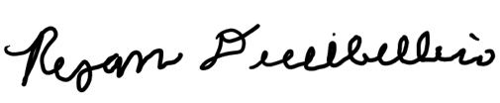

Date Signed: 9/12/2024

Member’s Printed Name: Lawrence Terrell

Member’s Signature:



Date Signed: 9/12/2024

Member’s Printed Name: Mina Brahmbhatt

Member’s Signature:

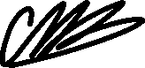

Date Signed: 9/12/2024

Member’s Printed Name: Nia Britton

Member’s Signature:



Date Signed: 9/12/2024

Member’s Printed Name: Kendall Kovacs

Member’s Signature:

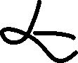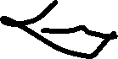

Date Signed: 9/12/24

# Appendix B: Functional Decomposition

# Appendix C: Target Catalog

*Table #: Target Catalog*

# Appendix D Figures and Tables

Table 20: Criteria Check for Criteria Comparison

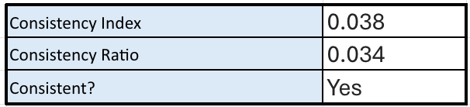

Table 21: “Seals Contents” Selection Criteria Ranks

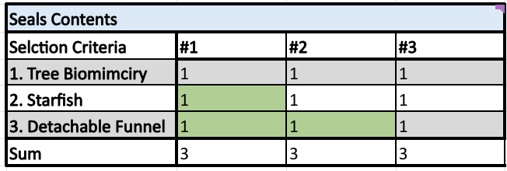

Table 22: “Seals Contents” Selection Criteria Normalized Ranks

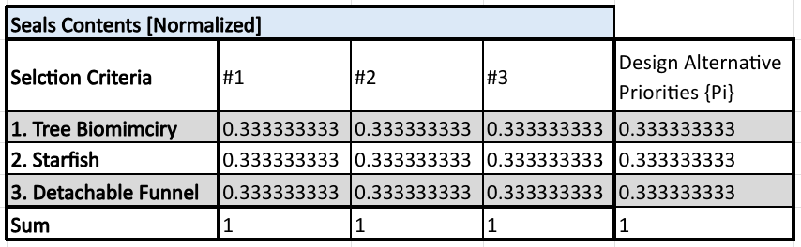

Table 23: Consistency Check Charts for “Seals Contents”

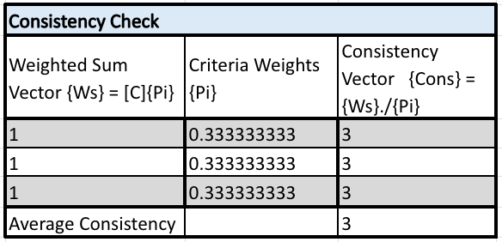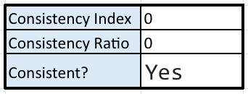

Table 24: “Simulant Entrance can be Resealed” Selection Criteria Ranks

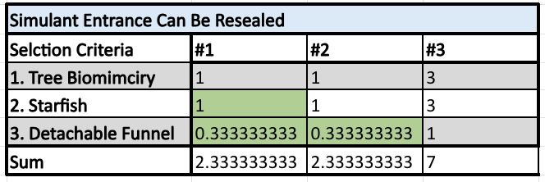

Table 25: “Simulant Entrance can be Resealed” Selection Criteria Normalized Ranks

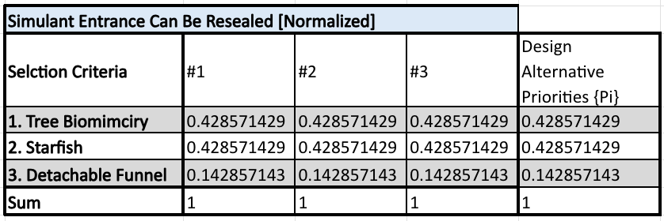

Table 26: Consistency Check Charts for “Simulant Entrance can be Resealed”

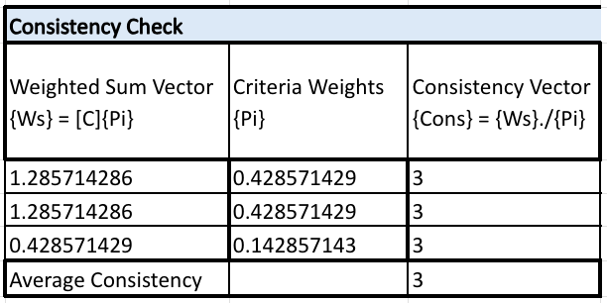

Table 27: “Lofts Simulant” Selection Criteria Ranks

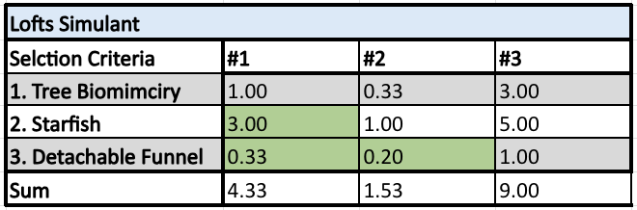

Table 28: “Lofts Simulant” Selection Criteria Normalized Ranks

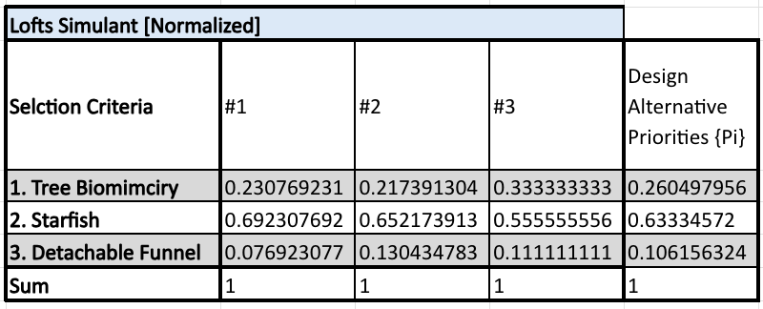

Table 29: Consistency Check Charts for “Lofts Simulant”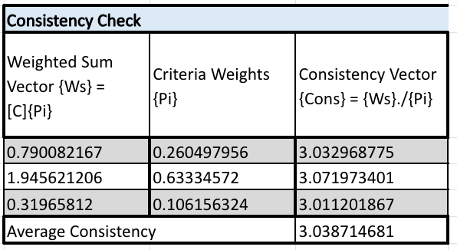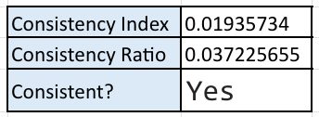

Table 30: “Funnel Mechanism Deposits Simulant” Selection Criteria Ranks

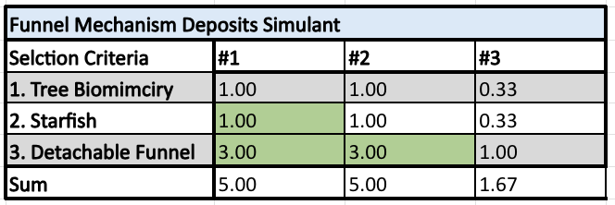

Table 31: “Funnel Mechanism Deposits Simulant” Selection Criteria Normalized Ranks

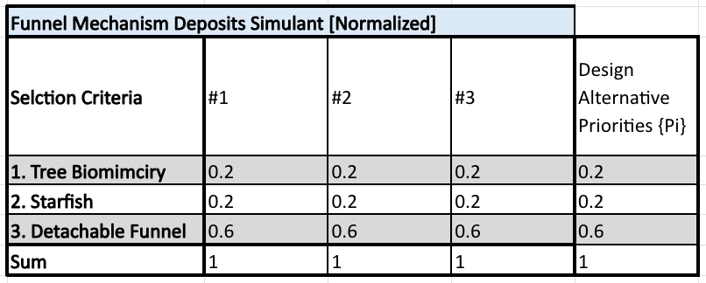

Table 32: Consistency Check Charts for “Funnel Mechanism Deposits Simulant”

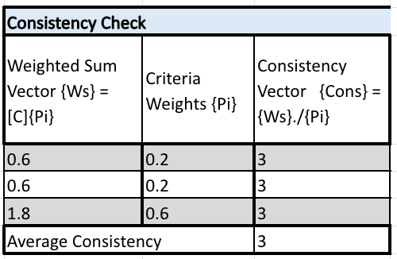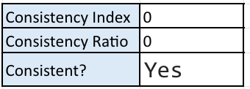

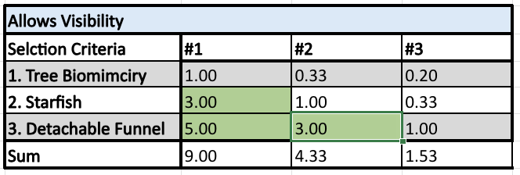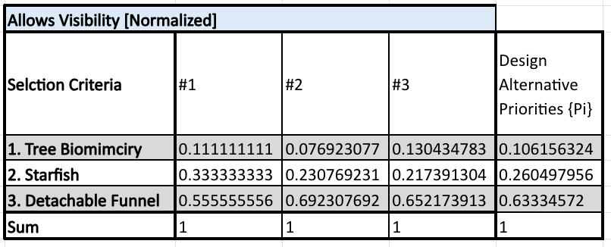

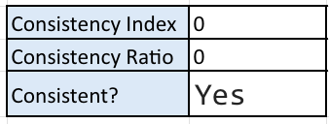

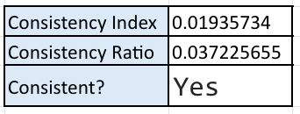

# References

*Amy Cassady*. LinkedIn. (n.d.-a). <https://www.linkedin.com/in/amy-cassady-10b6132/>

*Amy Fritz*. LinkedIn. (n.d.-b). <https://www.linkedin.com/in/amy-fritz-67508bb5/>

ASI, CSA, ESA, JAXA, & NASA. (2016, February 9). Dust Mitigation Gap Assessment Report. International Agency Working Group.

Belt, J. (2018, May 8). *Jacobs Space Exploration Group*. osbp.nasa.gov. [https://osbp.nasa.gov/docs/event-presentations/2018_05/08/1005_NASA-Primes-Jacobs-AMENTUM SPACE EXPLORATION GROUP_JBelt.pdf](https://osbp.nasa.gov/docs/event-presentations/2018_05/08/1005_NASA-Primes-Jacobs-JSEG_JBelt.pdf) 

*Brian Troutman*. LinkedIn. (n.d.-c). <https://www.linkedin.com/in/brian-troutman-7a795a8/>

*Florida A&M University-Florida State University College of Engineering*. FAMU-FSU Engineering. (n.d.). <https://eng.famu.fsu.edu/>

John, K., Chambers, W., Buhler, C., & Meyer, M. (2022, June 8). The Challenge of Lunar Dust. NASA.

NASA. (2024, September 9). *About NASA*. NASA. <https://www.nasa.gov/about/>

McConomy, S. (2018, September 10). 20 Project Scope 180910. Tallahassee; Canvas.

McConomy, S. (2024, August 24). 2025 SD Teams Assignment 240903. Tallahassee; Canvas.

*Sand mining: how it impacts the environment and solutions*. World Economic Forum. (2023, September 21). <https://www.weforum.org/agenda/2023/09/global-sand-mining-demand-impacting-environment/#:~:text=Sand%20mining%20from%20rivers%20and,tourism%20industry%2C%22%20says%20UNEP>.

Tecson, D. (2024, February 18). *Understanding the different types of protective coatings for cars*. NCS National Carwash Solutions. <https://ncswash.com/understanding-the-different-types-of-protective-coatings-for-cars/#:~:text=Protective%20coatings%20are%20usually%20made,provide%20a%20firmer%20protective%20film>.

*What is CFD: What is Computational Fluid Dynamics?*. SimScale. (2021, September 18). <https://www.simscale.com/docs/simwiki/cfd-computational-fluid-dynamics/what-is-cfd-computational-fluid-dynamics/>